# Contents

Contents

Purpose

Glossary of Terms

Adobe Pro

Archiving

CC

CIR

COS

Date Stamper

DME

DS3

HCB

ICF

Non-Certified Providers

OCS

Off Site Storage

Organization

PCA

PST

Res Hab

RSL

SME

Tab

Important Icon

Arrows

Provider - ALH – General Info:

Provider - ALH - License Issued:

Provider - ALH - License Made Conditional:

Provider - ALH - Modified License Issued:

Provider - ALH - Report of Inspection Issued:

Provider - BCU General Info:

Provider - BCU Variance - Approved:

Provider - BCU Variance - Continuance:

Provider - BCU Variance – Denial/Closure:

Provider - Certification - Application Complete:

Provider - Certification - Application Received:

Provider-Certification-Application Withdrawn:

Provider - Certification – Information Requested for Application Evaluation:

Provider - Certification – Issued Notice of Incomplete Application:

Provider - Certification – Information Received:

Provider – Certification - Notice of Denial or Other Sanction*:

Provider-Certification-Returned Incomplete Application:

Provider - Compliance - Certification Not Compliant:

Provider - Compliance - Corrective Action Complete:

Provider - Compliance - Issued Notice to Correct:

Provider - Compliance – Status Update:

Provider – Provider - Audit/Overpayment Finding:

Provider – Provider - Contact:

Provider-Record-Conversion:

Provider-Record-Location:

Provider - Sanction – Appeal:

Provider - Sanction - Appeal – Resolution:

Provider - Sanction – Education:

Provider - Sanction - OIG Exclusion:

Provider - Sanction – Other:

Provider - Sanction - Prepayment Review:

Provider - Sanction - Restriction/Withholding of payments:

Provider – Sanction - Suspension from Medicaid:

Provider – Sanction - Termination from Medicaid:

Provider - Training – Care Coordination:

Provider - Training – Critical Incident Reporting:

Provider - Training – Personal Care Assistance:

Provider - Training – Residential Supported Living:

Provider – Waiver – CPR/FA:

Application Received

Hard Copy (Front Desk or Fax)

Date Stamping Machine

Email

Adobe

New Providers

Details Tab

Medicaid Codes Tab

Notes Tab

Application Received

Record Location

SharePoint Application Tracker

Checklists

HCB

PCA

Electronic Folders

New BCP Account

Approval Review Process

Prioritization

Additional Locations, Multiple Locations and Multiple Services

Beginning a Review

Checklist use

Pend Letters

DS3 Notes

Special Notes

Extensions

BCU & verification form

Exclusion lists

Licenses

Car Registration

Care Coordinators and Care Coordination Agencies

Care Coordination Agencies (Sole Proprietor)

Hab Homes

Respite/Day hab

Approvals

Filing

Approved Providers

Details Tab

Contacts

Categories of Service (Medicaid Tab)

All Agencies

Care Coordination (Individual)

Care Coordination (Agency)

PCA

Respite

Day Habilitation

Residential Habilitation

RSL

All other services

Linking Providers Care Coordinators and Residential Habilitation Homes

Agents, Agencies and Renderers

Notes

Care Coordinators

All Providers

PCA

RSL

Certification Forms

Folders

HCB (Blue)

Care Coordinators

PCA (Grey)

Activating Providers

Details

Contacts

Medicaid Codes

Recertifications

Recertification Letters move down?

Report

Mail Merge

Envelopes

Notes

Reviews

Pend Notices

DS3 Details

Most Providers

RSL

PCA

Contacts

Owners

Program Administrators

Back Up Care Coordinators

Medicaid

Recertification

Extensions

Agents

Renderers

Agencies

Notes

Pend Notices

Denial Letters

Contact Notes

Late Recertification Applications

Recertification Application approvals

Other Application Types

Withdrawls

Changes in Business Type

Agency sale

Add location

Add CC

Add service

Denials

Letters

Notes

Administrative Hearings

Closures

Voluntary Closure

Involuntary Closure

Archiving

Offsite

Voluntary Closed

Involuntary Closed

Recalling a file

Reports

Weekly

Monthly

Ad Hoc on demand

Non HCB or PCA Certified Providers

DME

SME

LTC

ICF

# Purpose

The purpose of this procedure is to instruct staff in the processing of an application from the time it arrives (Initial Application or Recertification) to the time it leaves (Off Site Storage and Archiving). This includes the variety of information collected and in some cases what reports the information entered affects.

# Glossary of Terms

Adobe Pro- any version of Adobe that is not Reader. Pro’s features include file merging, splitting, page insertion or deleting, redacting and adding a footer plus many other useful tools

Archiving- this is only for closed providers either voluntary (7 year retention) or involuntary (10 year retention). After the retention on site has been met (1 year minimum) files can be sent to storage for the remaining time until destruction which is handled at the storage site. Archives should contact SDS and specifically the unit manager regarding files before actually destroying them.

CC- Care Coordinator

CIR – Critical Incident Report

COS- Category of Service, this is the variety of services provided under the HCB Waiver or alternately the type of PCA service the agency provides. Almost all agencies will have a Core Waiver or PCA COS but Care Coordinators will only have the Care Coordination (Individual) COS while contracted Residential Habilitation Homes will have none.

Date Stamper- this is the machine located in the copier room and is used to stamp incoming hard copy documents with SDS CERT and the date received

DME-Durable Medical Equipment, these providers are not certified by SDS but the Waiver workers who process the client applications and POCs use DS3 for reference for this type of provider. Providers provide services such as Lifeline which is a service that is important to many clients and these providers do show on the public Provider Search Tool

DS3- SDS’ mainframe database built originally by Chris Hamilton and being replaced by the Harmony System in 2014-2017 in phases.

HCB-Home and Community Based Waiver, the federal program that serves a large percentage of our clients

ICF-Intermediate Care Facility, an out of state assisted living type facility for IDD clients who have SOA care coordinators. A specialized facility to handle a very specific population. These facilities have a separate certification process

Non-Certified Providers- includes the SME and DME providers who only have end dates and are maintained by the unit’s SST to assist Waiver personnel who process POCs

OCS-Office of Children Services, these are foster homes for our CCMC youth clients and are Habilitation providers contracted to an agency. These providers NEVER have a start date on the Medicaid tab as there was a MOU with OCS that the homes would remain confidential in our system and if there was a start date the home will show on the PST. These homes are generally to a Foster Parent and will frequently be the parent’s names instead of an agency. Despite this they are entered as an organization or they cannot be linked to their provider agency.

Off Site Storage – a form of archiving the older materials of an active provider to reduce hard file folder size. Files are sent off site and kept for 20 years.

Organization – the name of the provider type in DS3

PCA – Personal Care Assistance, these agencies are either Agency Based or Consumer Direct and carry a designation of U3 for one of the two (which one?)

PST- Provider Search Tool, this is the public facing tool found on the state’s website and used to find providers of services in a specific area or for a specific service. The exception should be that the res hab homes that are contracted to an agency should never show up especially OCS homes. Non-certified providers such as those who provide Lifeline or such as Geneva Woods which has durable medical equipment should show up. The Report manager has a report by the same name that is used to create the state wide list of Care Coordination Agencies and Care Coordinators list as well as a list of PCA Agencies which is used by Care Coordinators to provide client choice. The lists are posted in both PDF and XLSX formats to provide user friendly versions.

Res Hab – Residential Habilitation

RSL – Residential Supported Living or ALH, Assisted Living Home

SME – Specialized Medical Equipment

Tab -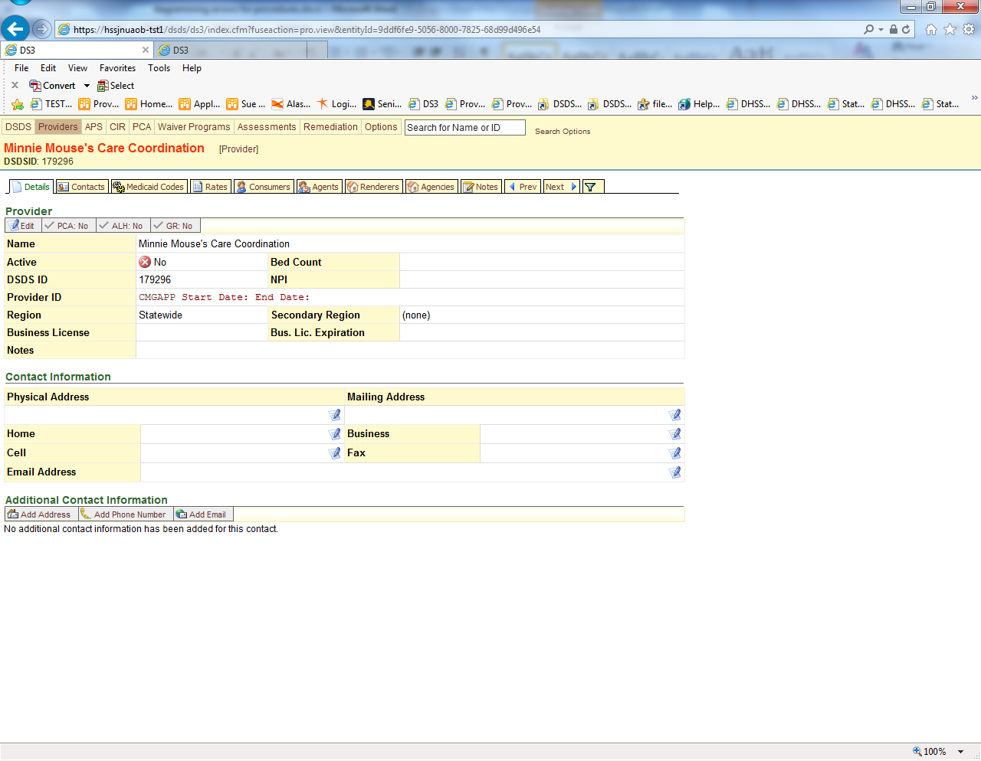

Important Icon – 

Arrows -

# Note Titles

Provider - ALH – General Info: Entry is used for notes concerning general ALH or licensing issues or information that does not meet one of the other ALH note topics.

Provider - ALH - License Issued: Assisted Living licensing program issued a provisional or biennial license that has not been modified.

Provider - ALH - License Made Conditional: The existing or issued license had a condition placed on the license as part of an enforcement action.

Provider - ALH - Modified License Issued: Assisted Living licensing program issued a provisional or biennial license that has been modified. A modification includes change in capacity, population served, administrator, ownership, physical address, mailing address, etc.

Provider - ALH - Report of Inspection Issued: Assisted Living licensing program completed an annual or renewal inspection and issued a notice of violations if requirements were not met. The notice may also include enforcement actions if applicable.

**Provider - BCU General Info:** Entry is used for notes concerning general BCU or variance issues or information. IS NOT USED for any type of Variance action.

**Provider - BCU Variance - Approved:** Provider has been granted a background check variance. In date field, enter the ***effective date*** of variance (this is the date the Commissioner signed the variance). In the body of the note, enter: end date of variance, Provider #, individual’s name and barrier end date in text box. Add brief notes of any conditions, etc. regarding the variance if applicable.

**Provider - BCU Variance - Continuance: P**rovider has been granted a background check variance continuance of an existing variance. In date field, enter the ***effective date*** of the variance (this is the date the Commissioner signed the original variance). In the body of the note, enter: end date of variance, Provider #, individual’s name and barrier end date in text box. Add brief notes of any conditions, etc. regarding the variance if applicable.

**Provider - BCU Variance – Denial/Closure:** Provider’s variance has either closed or a request was denied. If the variance closed, in the date field enter the ***effective date*** of the variance (this is the date the Commissioner signed the original variance). If the variance request was denied, enter the date the Commissioner denied the request. In the body of the note, enter: end date of variance, Provider #, individual’s name and barrier end date in text box. Add brief notes of any conditions, etc. regarding the variance if applicable.

Provider - Certification - Application Complete: Application is signed and has all required attachments. Enter date in date field once application is complete. Indicate in text box the name of staff application is forwarded to and other applicable information.

Provider - Certification - Application Received: Applicant has submitted an initial, renewal, or additional service application. Enter date received by SDS in date field and indicate the type of application and services in text box.

Provider-Certification-Application Withdrawn: Applicant has chosen to withdraw their application or certification. Enter date written notification received by SDS.

Provider - Certification – Information Requested for Application Evaluation: Application is complete but applicant did not have the elements needed to evaluate or make determination that certification requirements are met, prompting a request for more information. Enter date requested in date field. Copy and paste pend letter into case note.

Provider - Certification – Issued Notice of Incomplete Application: Initial or renewal application was determined to be incomplete and applicant was sent written request to submit items and given due date. Enter date notice sent in date field and describe needed items and due date or may copy and paste email in text.box.

Provider - Certification – Information Received: Information was requested from a provider, either during the application or recertification process and was received. Information requested was not of a Compliance nature. Enter date requested in date field. Briefly describe requested items in text box, method of contact and due date to submit items or information

**Provider – Certification - Notice of Denial or Other Sanction*: Provider was issued notice to deny initial application, deny renewal of certification, terminate, suspend or other sanction described in 7AAC 105.410. Record date of notice in date field. Copy and paste denial letter into case note**. *Disregard this part of the note, use appropriate sanction note type as described below.

**Provider-Certification-Returned Incomplete Application:** Entire application was returned to the provider as it was deemed incomplete because the provider either failed to submit the information when requested or failed to submit adequate information or documentation when requested.

**Provider - Compliance - Certification Not Compliant:** Substantiated that a provider does not meet certification requirements through a discovery made from critical incident or complaint investigation, onsite review, evaluation of renewal application, or other information received by the Department. This note category *does not* include applicant that is not currently certified. Record date of substantiation in date field (this becomes the ***tracking date*** for this compliance issue), and enter requirement(s) not met in text box.

**Provider - Compliance - Corrective Action Complete:** Provider has provided evidence corrected action was taken and requirement(s) is met. Enter the ***tracking date*** in the date field. Enter correction made in text box along with the date the evidence was provided to the department, along with any other applicable information. (Note: This note is used when all items identified using this ***tracking date*** have been corrected and the Non-Compliance Item can be closed. For non-compliant status update, use the “Provider – Compliance – Status Update” note entry.

**Provider - Compliance - Issued Notice to Correct:** Provider issued report of findings, email, or other written correspondence requesting correction and a timeline to correct. (This note category *does not* include applicant that is not currently certified.) Enter the ***tracking date*** in the date field. Record date sent to provider in the text box and briefly describe the method of notice, correction needed, date due and confirmation that provider received notice. Emails may be copied into text box.

**Provider - Compliance – Status Update:** Provider has provided an update on completing requirements identified in the “Notice to Correct” notification sent to the provider. Enter the ***tracking date*** in the date field. In text box, enter the information the provider has given on correcting the identified deficiencies. If the department allows a new due date, be sure this is indicated as well.

**Provider – Provider - Audit/Overpayment Finding:** State has issued notice that provider must reimburse the state of Alaska. Enter date issued to provider in date field and briefly describe the audit findings, which State entity issued the Notice (PIU, SDS, etc), amount owed, subsequent action(s), etc.

Provider – Provider - Contact: SDS has contacted the provider or provider has contacted SDS (examples; technical assistance, general concerns/question, clarification of requirement, resource need, etc.) Enter date of contact in date field and briefly describe contact method, issue and outcome in text field.

Provider-Record-Conversion: Provider hard copy file has been converted to established standardized format and is complete as of the date entered.

Provider-Record-Location: This is an internal tool so that files can be located within SDS among various employees in case the file needs to be located.

**Provider - Sanction – Appeal:** The provider was sanctioned and activated their appeal rights within the allotted 30 day time frame. The appeal is handled by AAGs in the AG office.

**Provider - Sanction - Appeal – Resolution:** The provider was sanctioned, appealed the sanction, and there is an outcome to report. Notes will include what those outcomes are.

**Provider - Sanction – Education: Provider has been sanctioned using 7 AAC 105.410 (6): Mandatory attendance at provider education sessions; including one-on-one sessions**. This sanction comes with 30 days appeal rights.

**Provider - Sanction - OIG Exclusion:** The provider has been added to the Federal OIG Exclusion list by Program Integrity Unit (PIU).

**Provider - Sanction – Other:** The provider has been sanctioned using any other sanctions listed under 7 AAC 105.410 other than those described in this document and listed in DS3.

**Provider - Sanction - Prepayment Review:** Provider has been sanctioned using 7 AAC 105.410 (8): Department review of all claims submitted by a provider before payment to the provider. This sanction comes with 30 days appeal rights.

**Provider - Sanction - Restriction/Withholding of payments:** Provider has been sanctioned using 7 AAC 105.410 (3): Restriction or withholding of payments to a provider. This sanction comes with 30 days appeal rights.

**Provider – Sanction - Suspension from Medicaid:** Provider has been sanctioned using 7 AAC 105.410 (2): Suspension of participation in the Medicaid program. This is a temporary sanction with 30 days appeal rights.

**Provider – Sanction - Termination from Medicaid:** Provider has been sanctioned using 7 AAC 105.410 (1): Termination from participation in the Medicaid program. This sanction comes with 30 days appeal rights. Once terminated, provider will be added to the State of Alaska exclusion list by Program Integrity Unit (PIU).

Provider - Training – Care Coordination: **Provider has attended SDS required Care Coordination training. Enter date of training in date field and the name of the training completed in text box.**

Provider - Training – Critical Incident Reporting: **Provider has attended Critical Incident Report training. Enter date of training in date field and the name of the individual who completed the training in the text box.**

**Provider - Training – Personal Care Assistance:** Administrator of PCA agency has attended SDS regulatory required training. Note of date of attendance in date field and in text identify the trainee

**Provider - Training – Residential Supported Living: Administrator/Owner has attended SDS training specific to Residential Supported Living Service. Note of date of attendance in date field and in text identify the trainee**

**Provider – Waiver – CPR/FA:** Provider has been granted a waiver of this requirement for an individual PCA staff. Note effective date of waiver in date field. Enter individual, city or town, and end date of waiver in text box and other applicable information.

# Application Received

## Hard Copy (Front Desk or Fax)

### Date Stamping Machine

All documents that come in via fax or front desk by drop off or mail need to be date stamped with SDS CERT <date rec’d>. The exact instructions for using the machine are posted by the machine.

## Email

### Adobe

Frequently applications and change forms come via email and before printing it is possible to use Adobe Pro to add a footer date stamp. (As of this writing there are only 2 copies of Pro in the unit, the SST and the unit Laptop have them but there is an Enterprise license available for everyone else pending management approval and request. When this is available for everyone the additional steps can be added here.)

* + - * All pages of the application at the time of receipt and subsequent documents sent after the application is pended must be date stamped whether they are received by fax, hand delivered, mailed, or emailed.

# New Providers

* + - * Within two business days of application receipt, Administrative Support staff inputs provider/applicant information into DS3 including application received date.
* DS3 note is entered identifying assigned reviewer using the “Provider - Provider - Record Location” case note title.

This is for new Organizations (agencies), Care Coordinators (individuals) and for Habilitation Homes that are contracted to an agency (OCS and Assisted Living homes are setup as an Organization)

1. While logged into DS3
   1. pull down the Provider Menu
   2. click on Create Provider

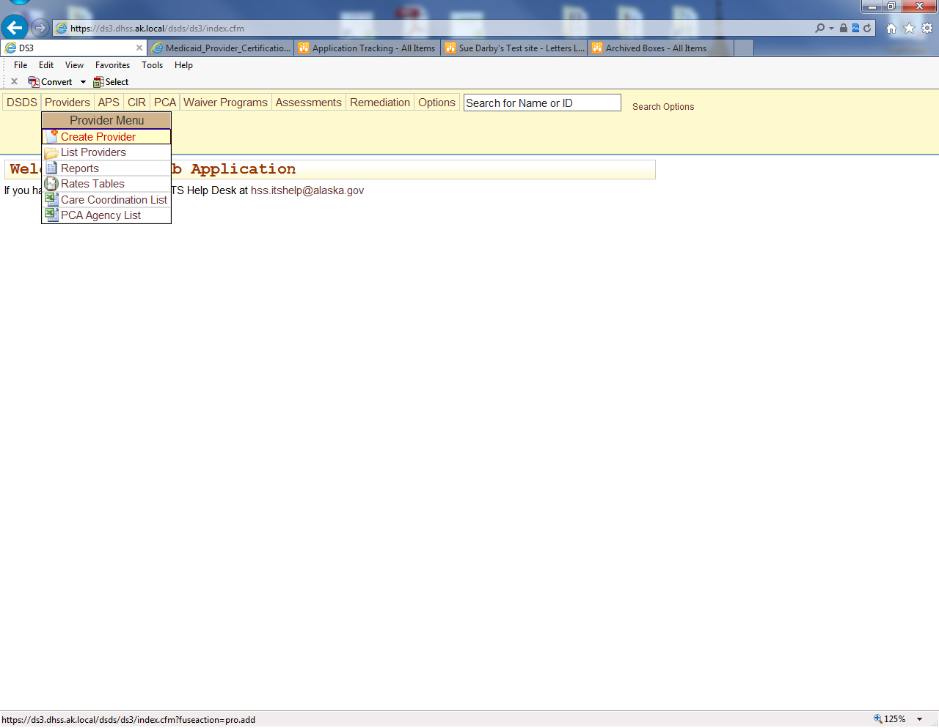

1. For an Agency (Organization) select the Organization Tab
   1. Add the Agency Name
   2. Add the Region served

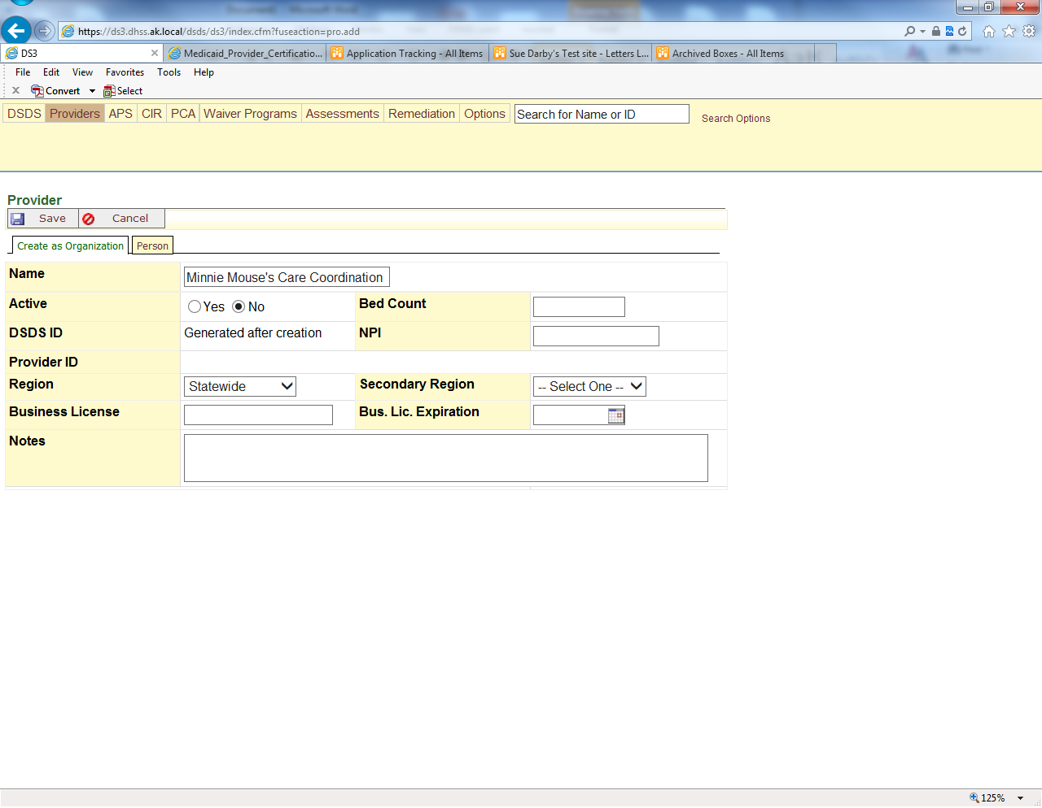

1. For a Care Coordinator select the Person Tab
   1. Add the person’s Name
   2. Add the Region served

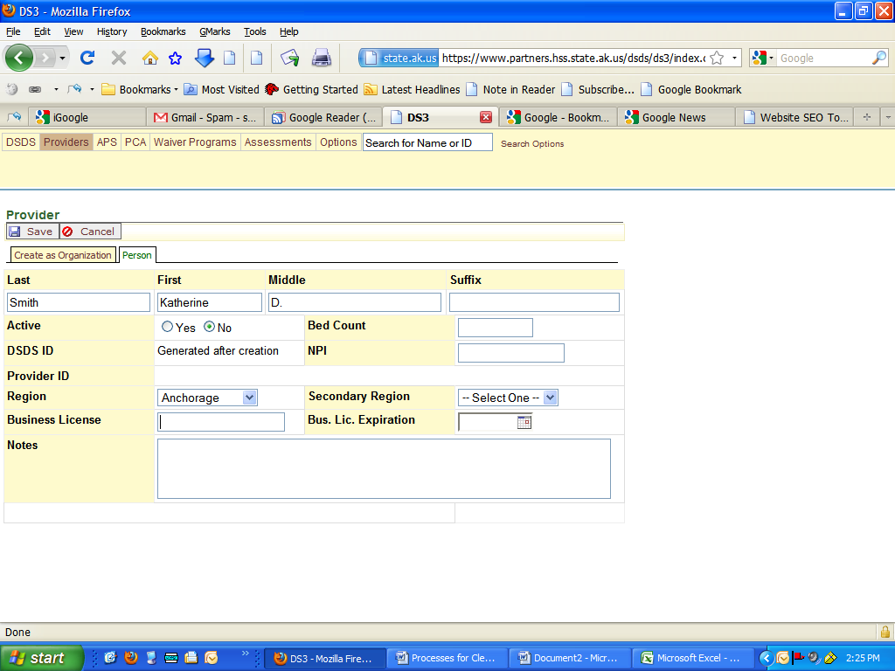

1. Save (both organization and person)

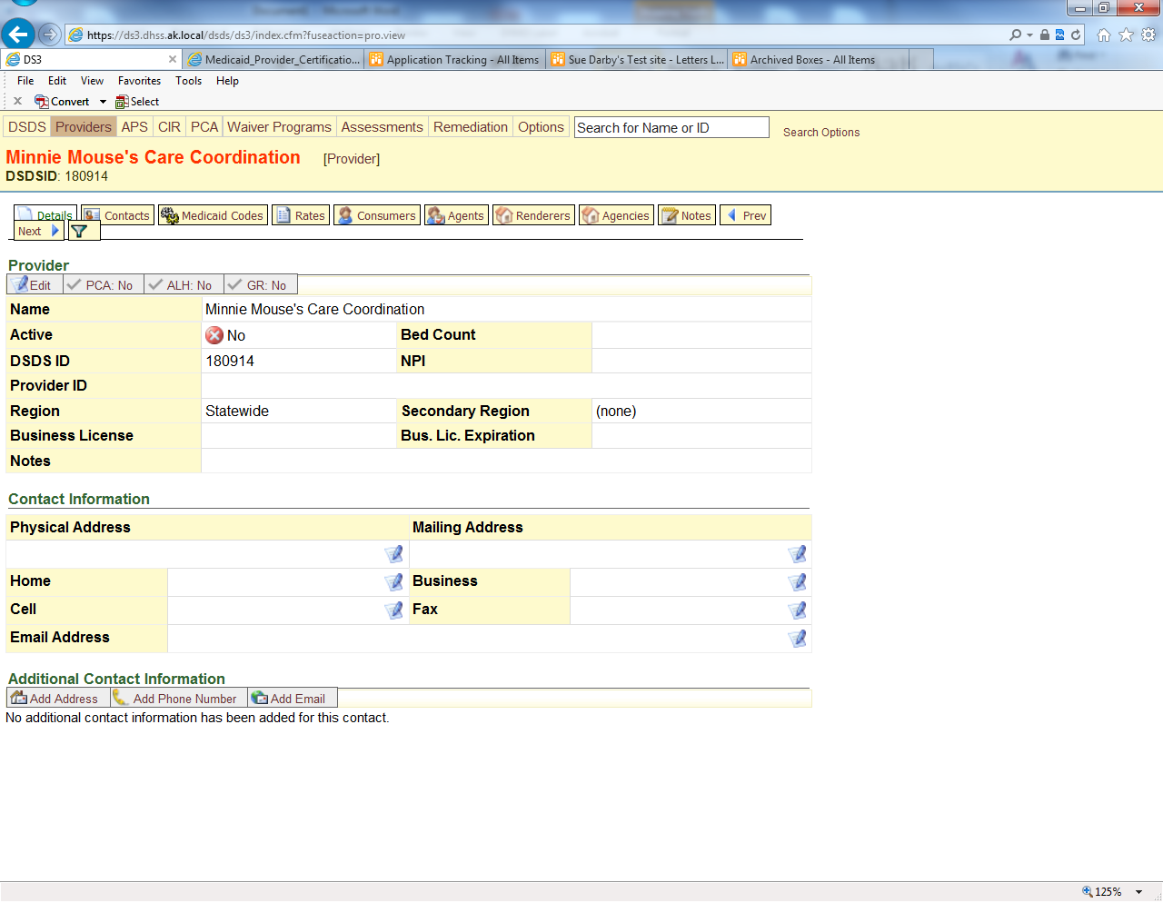

## Details Tab

All providers

1. update
   1. physical address
   2. mailing addresses
   3. phone, fax and e-mail information.

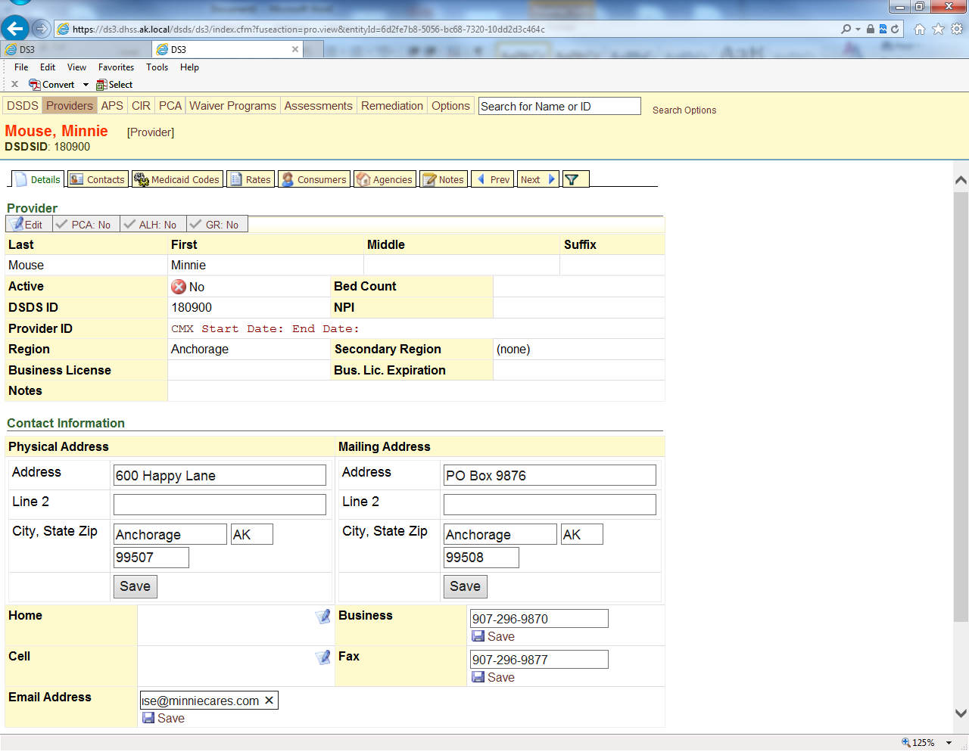

Hint: you can have all the boxes open as pictured above and then hit save for each once they are all filled in. Using tab between fields speeds up the entry process too.

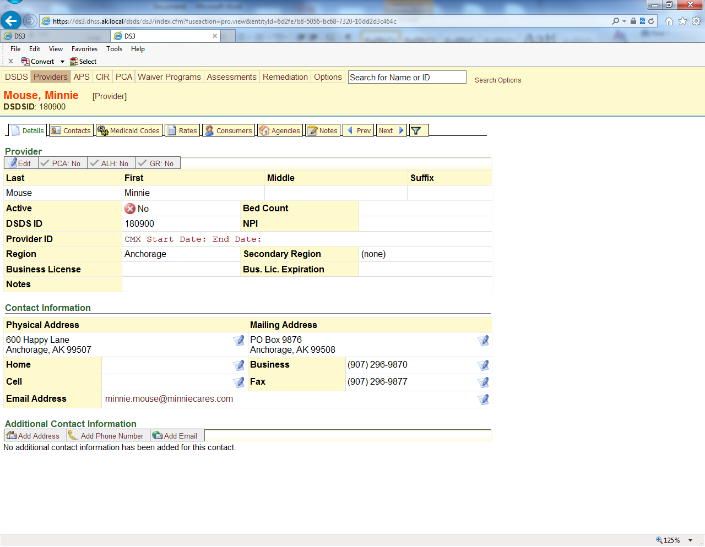

## Medicaid Codes Tab

* 1. In the first box, type CMAPP (care coordinator), CMGAPP (care coordination agency), HCAPP (all HCB services except assisted living and e-mods), RLAPP (Assisted living homes), PCGAPP (PCA Agencies) or EMAPP (E-mod providers) depending on the type of provider you are entering. For larger agencies you may have combinations of HC & RL etc based on what is allowed by regulations. These will have separate Medicaid Code entries.
  2. Do not enter any dates.
  3. Change the Status to “Inactive – Initial Application Pending”.
  4. Click the “Add” button.

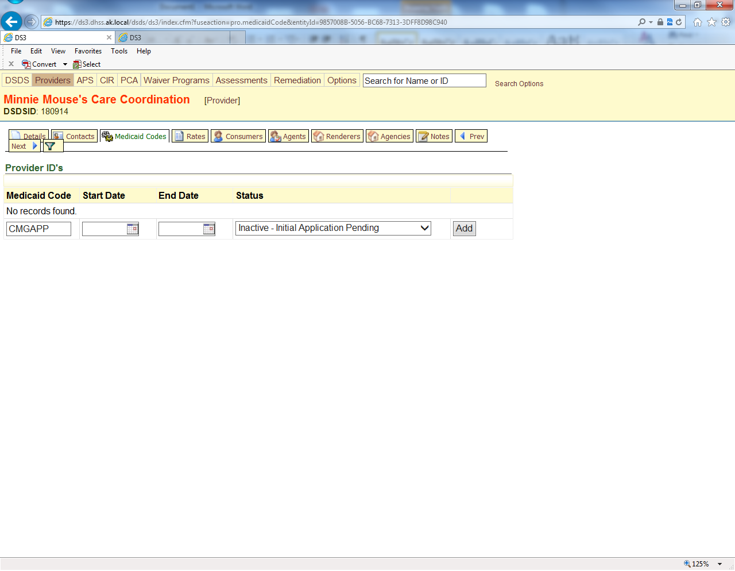

Or for an agency

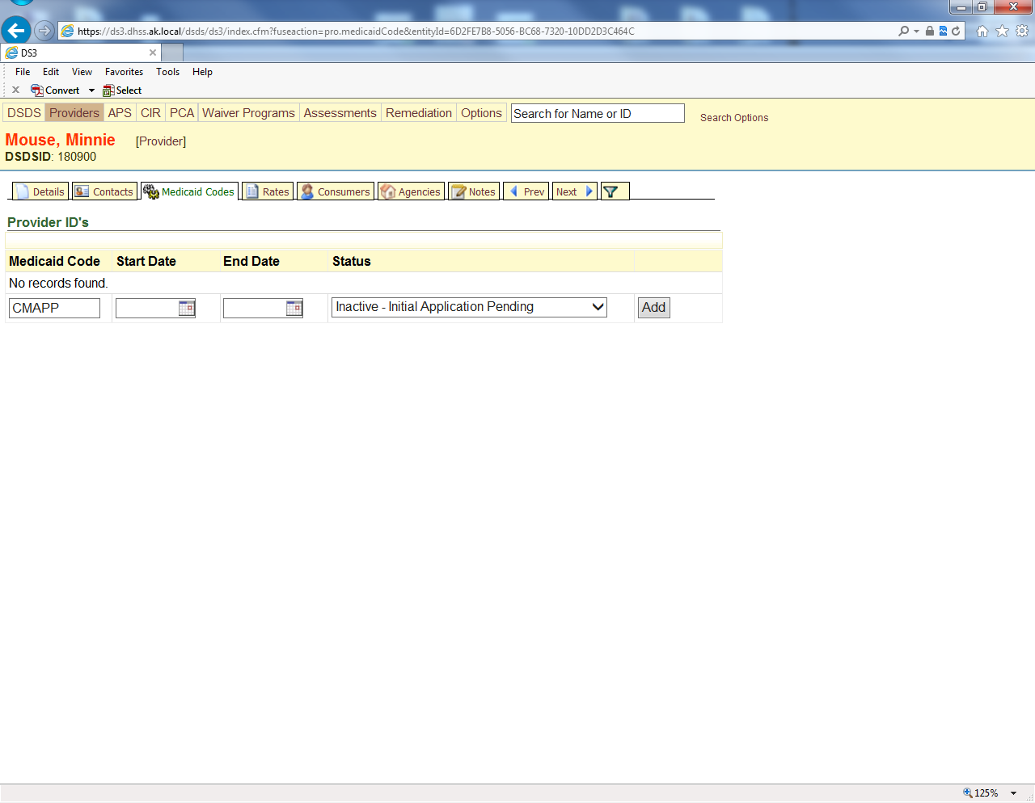

## Notes Tab

### Application Received

* 1. Click on “Add Note”. Click on the Select button to the right of the Title field. Choose the “Provider – Certification – Application Received” title and enter a note that states “Initial app rec’d” or “Recert rec’d”.

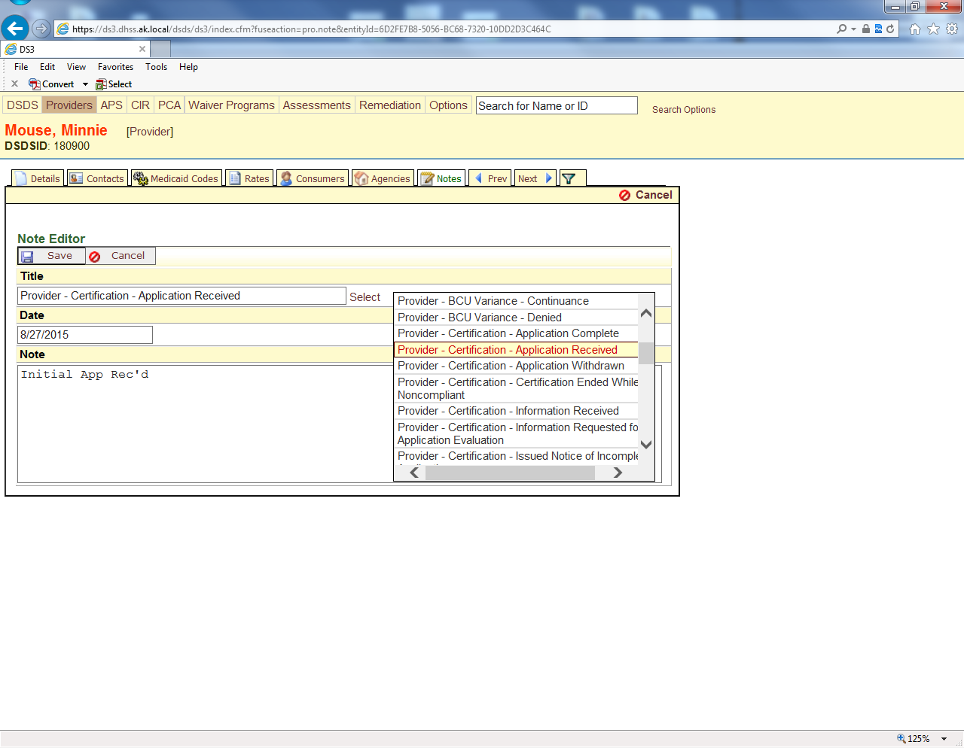

Note: if you are late with your note entry you can change the date field to the needed date and the system will also display the current date with the note too.

### https://cdn0.iconfinder.com/data/icons/trio-miscellaneous/32/reminder-3-512.pngRecord Location

1. Click on “Add Note”. Click on the Select button to the right of the Title field. Choose the “Provider – Record – Location” title and enter a notice that states “to (initials of reviewer).

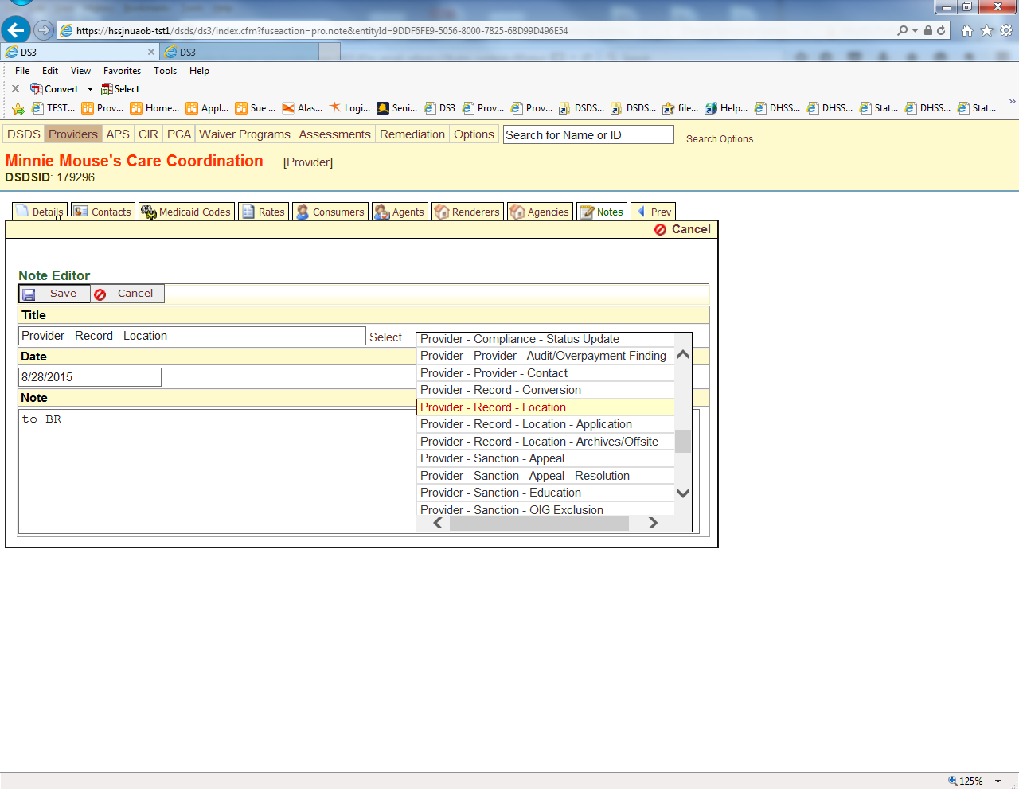

# SharePoint Application Tracker

The application may now be entered as follows in the SharePoint Tracking Log found at <https://go.dhss.ak.local/dsds/main/PQA/Lists/Application%20Tracking/AllItems.aspx>

The Tracker is used for Initial Applications, Recertifications and other changes that DS3 does not track such as time lines for processing. The process is the same for adding any of the mentioned application types. The tracker is very wide and can be expanded across both screens, because of this some of the below diagrams may only show part of the screen or be in multiple pieces.

To enter a new application into the tracker:

1. The main screen list
2. New Item

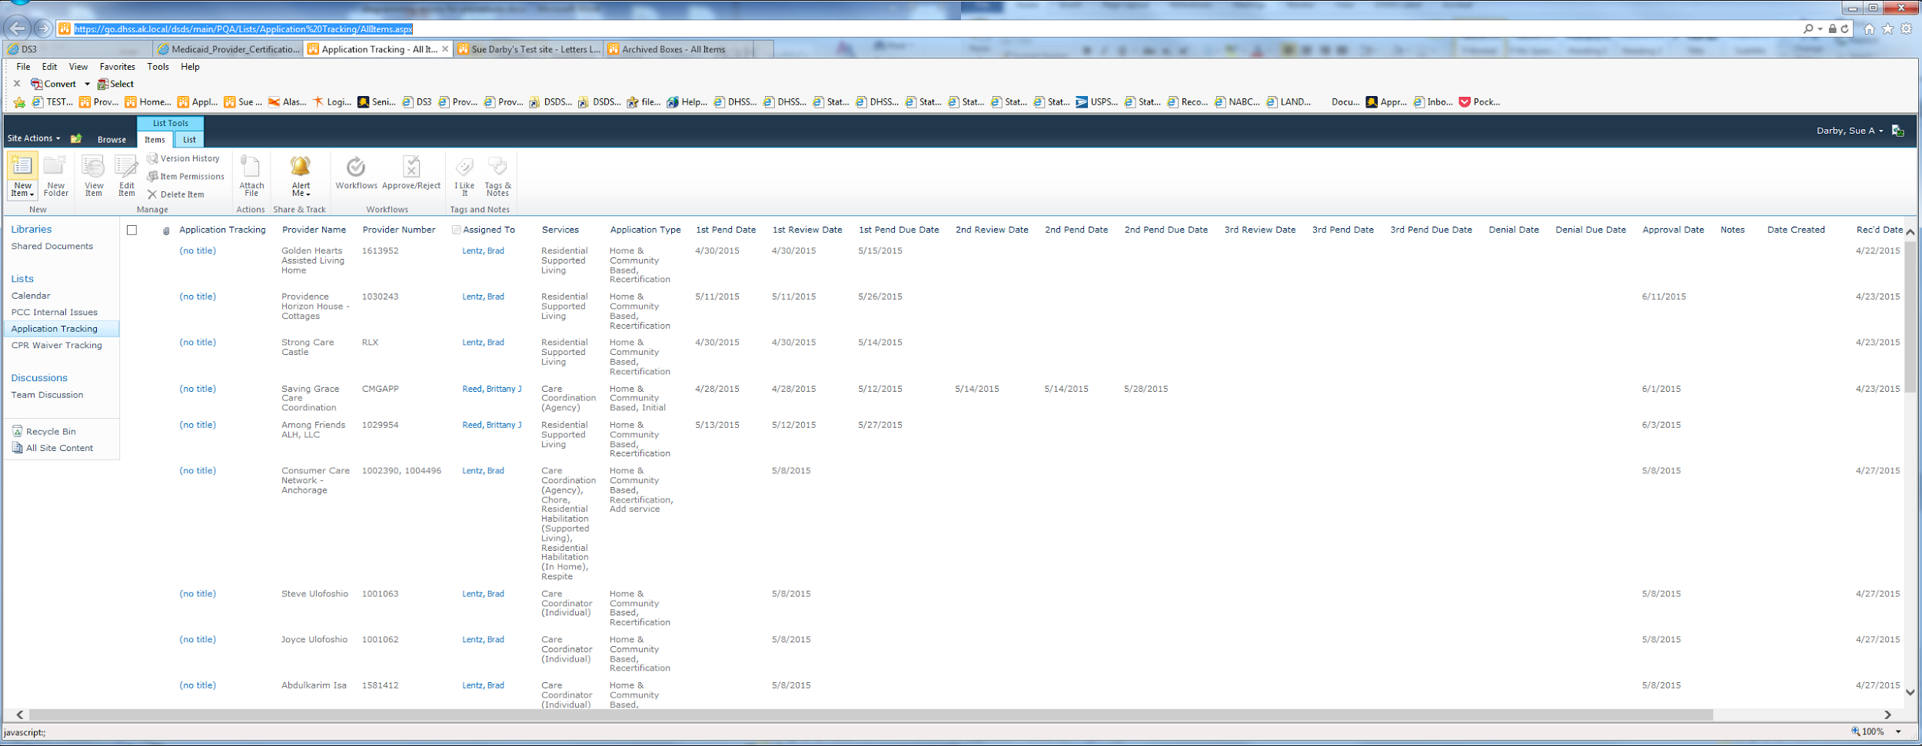

1. Adding a New Provider
2. Enter the Provider Name
3. The number (if it is a recertification) or the CMGAPP, HCAPP etc for an initial

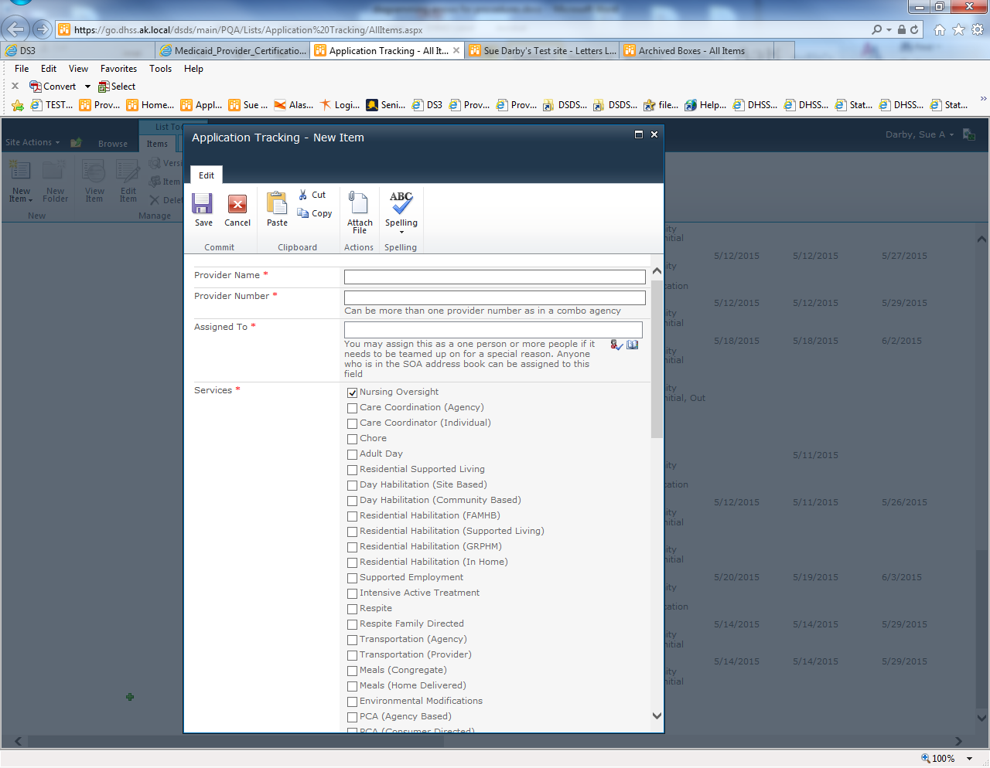

1. Assigning to a worker
2. Click the Open Book icon and search for the person the application will be assigned to
3. Search for the person
4. Add the person
5. Click OK

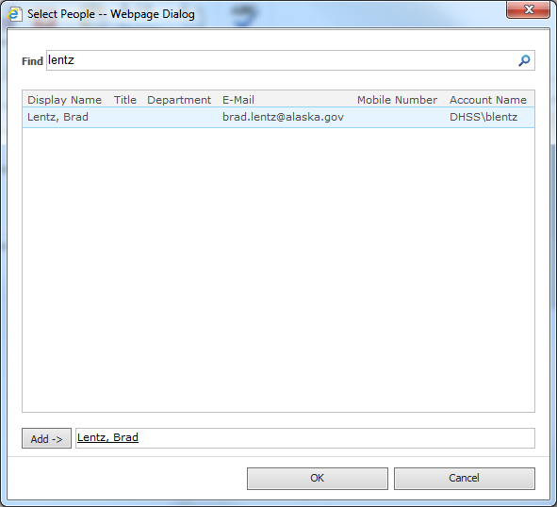

1. Continued from 2 because the form is long
2. Check the appropriate boxes for the services the individual or agency provides
3. Check the boxes for the Application type
4. Dates
5. Enter the Rec’d Date
6. Enter the date it will go to the staff member
7. Enter the provider’s end date if it is a recertification

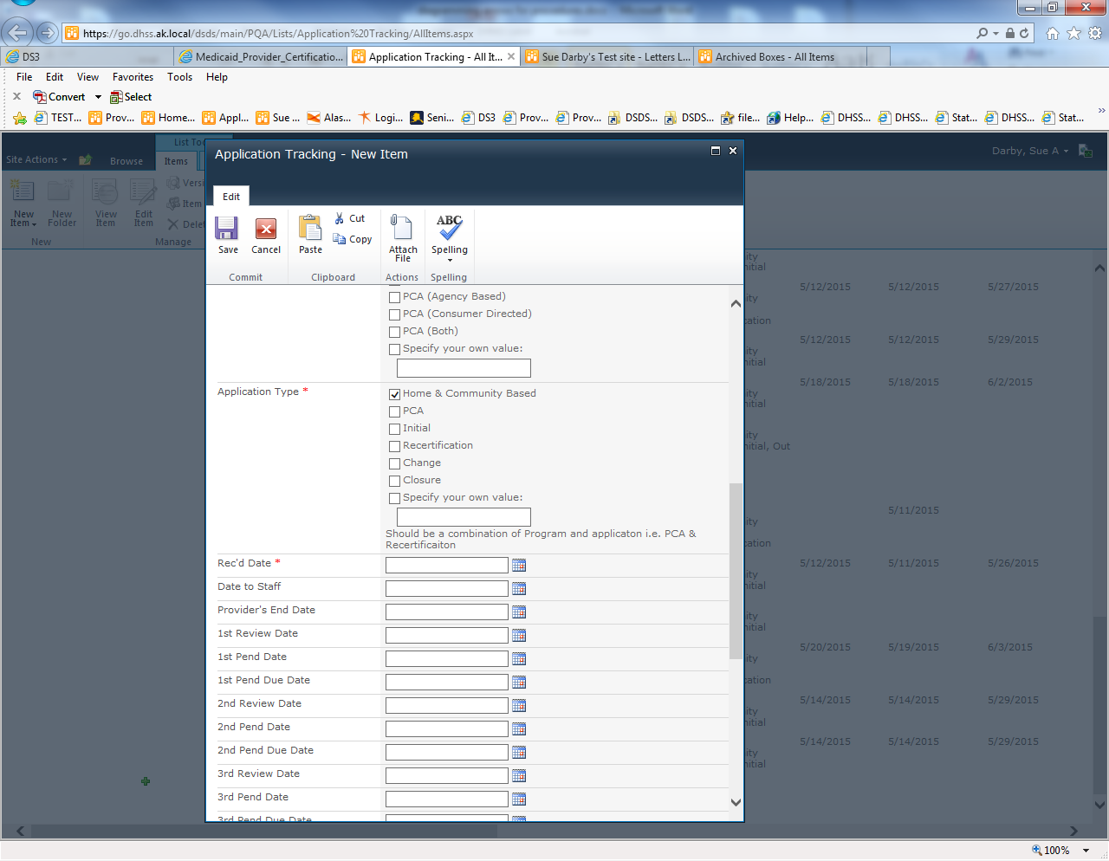

1. Continued again
2. Add additional notes regarding the application that might be helpful to the reviewer such as actions going on with other units or a site review
3. Continued for the last time
4. If the application is for a new admin or other unique change that does not have a field above use the Application Tracking field otherwise ignore it
5. Add the date the entry is being created (used to track application start to end processing time)
6. Save

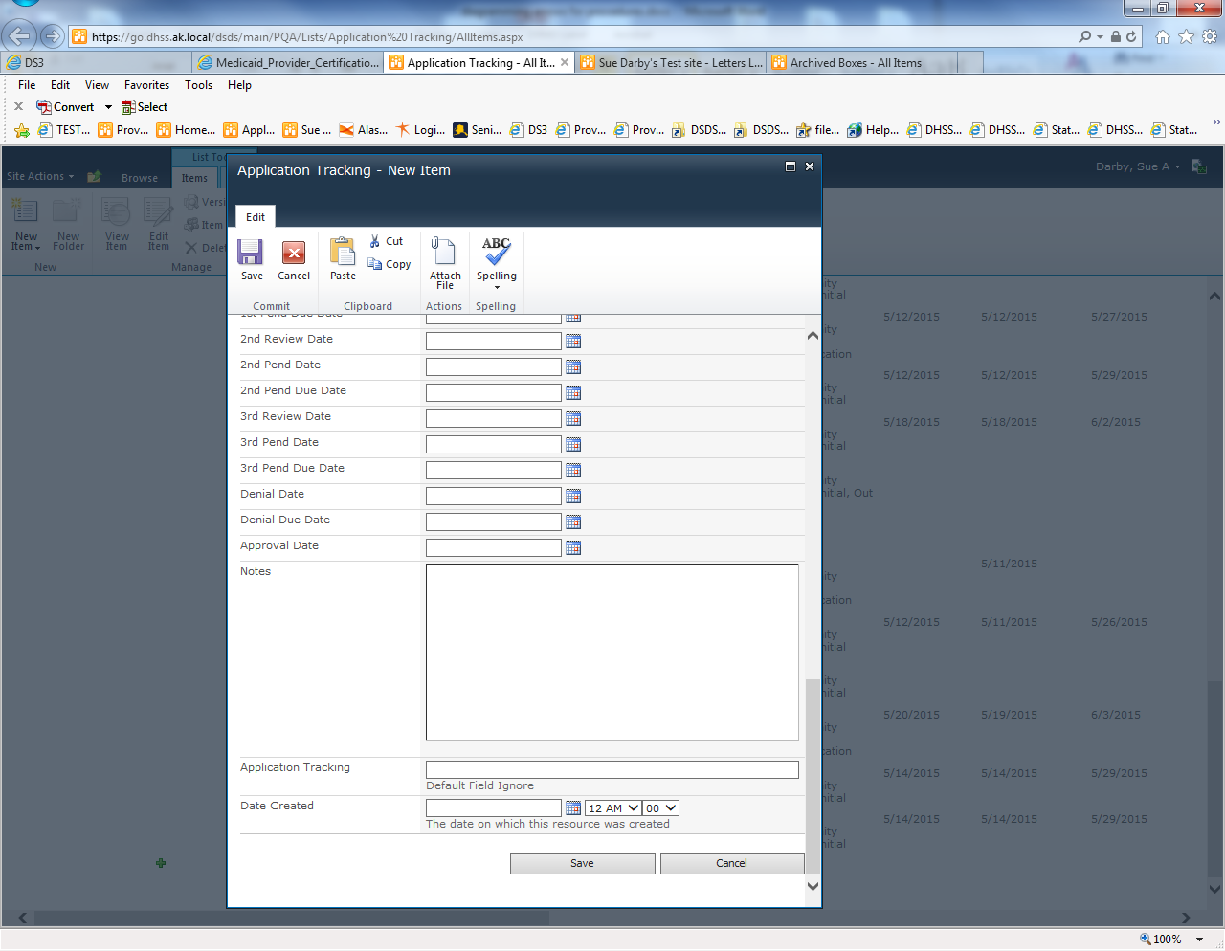

An Example

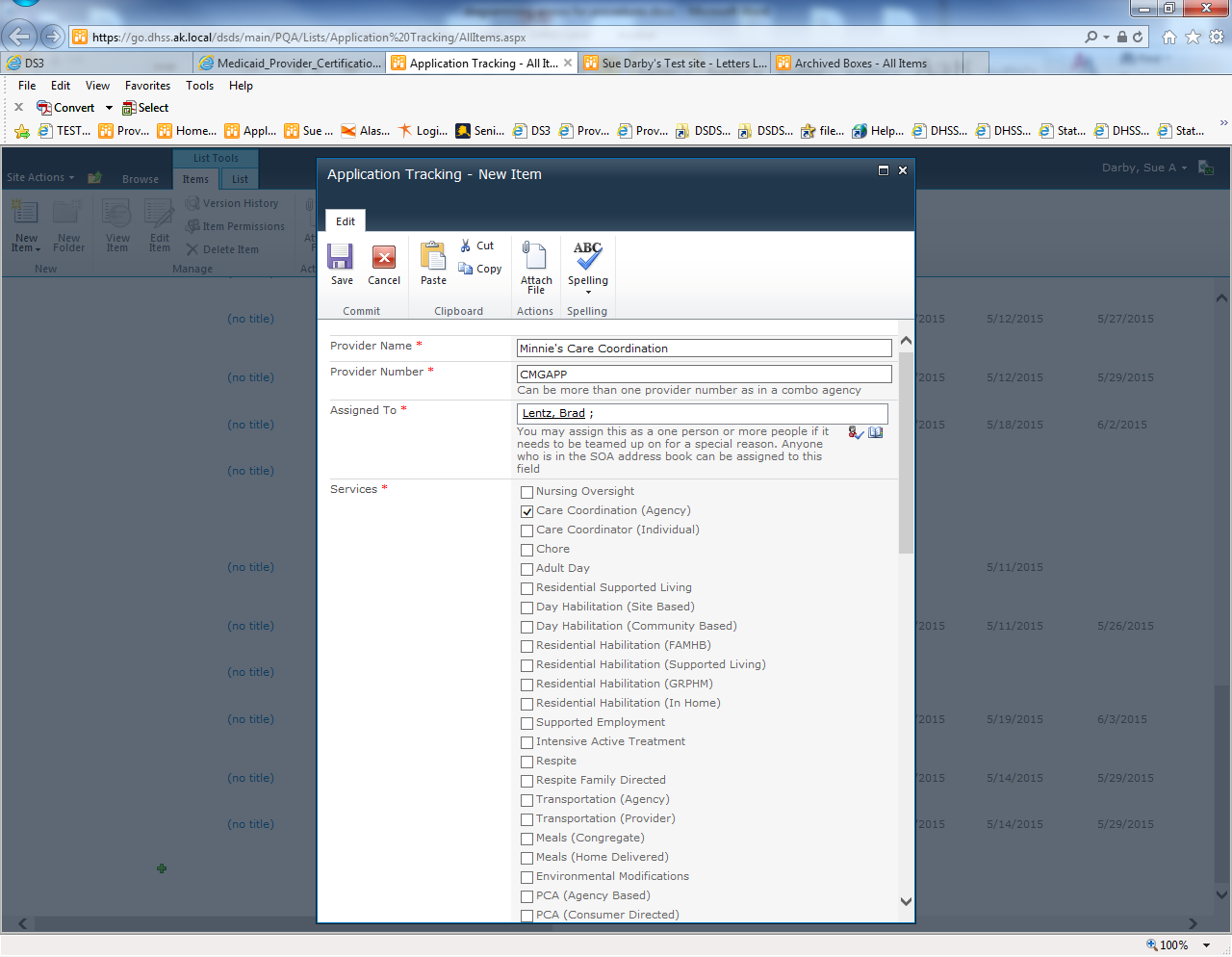

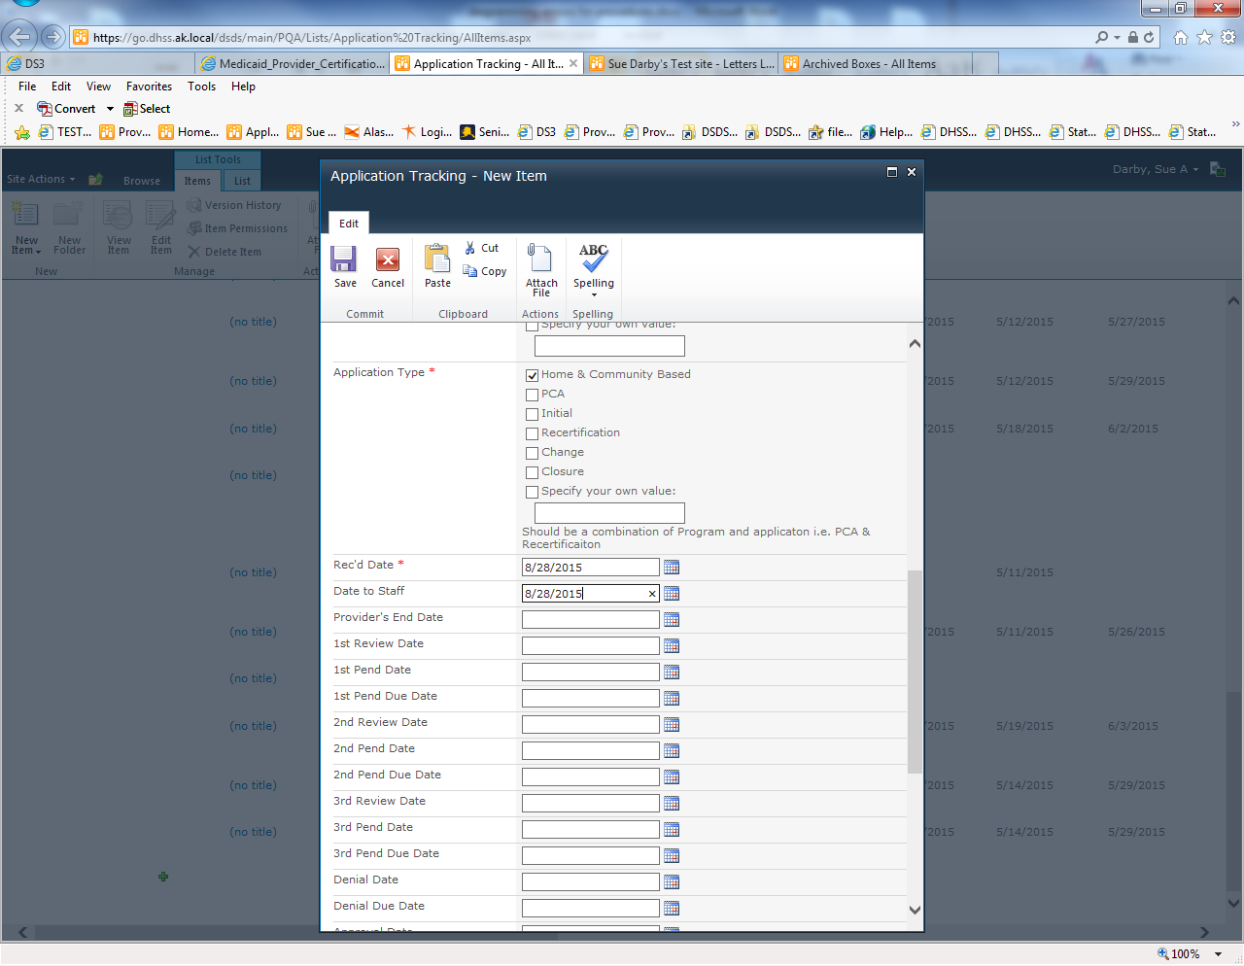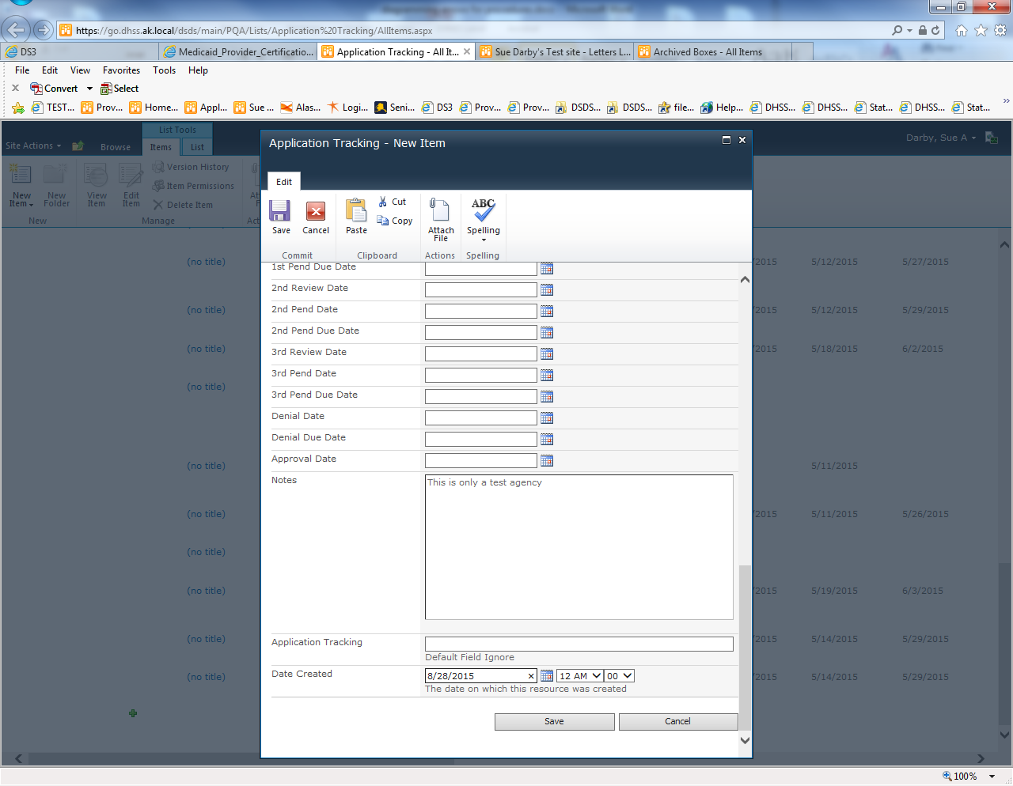

Final Results

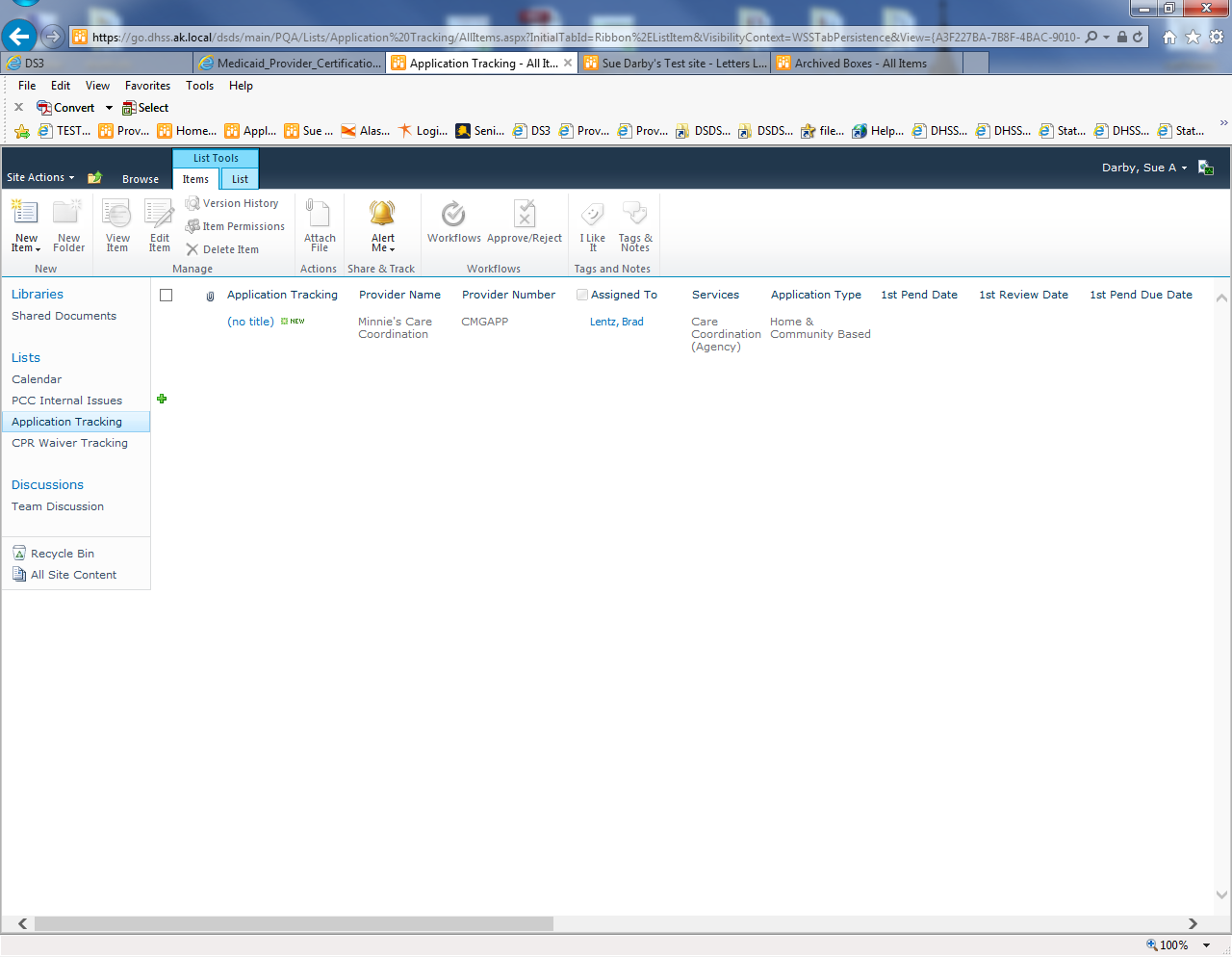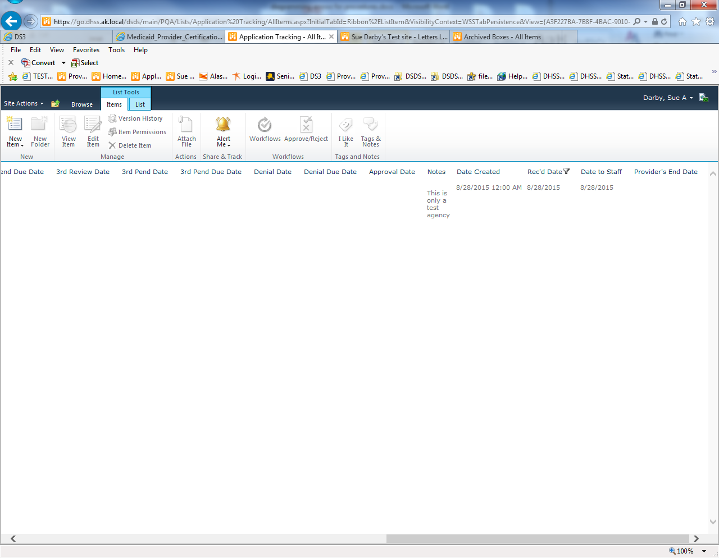

# Checklists

G:\Provider Certification & Compliance\Provider Screening & Foldering Checklists

## HCB

HCB Checklist NEW Regulations Updated -9-10-15 .xlsm This is a macro driven file but due to State computer setting it cannot be a template so do NOT hit save. Just print the final list.

Matrix sortable of Waiver Initial Cert new Regs 070115.xlsx this is a handy cheat sheet of the requirements for certification that is sortable.

1. Blank Checklist
   1. Clear all boxes clears the check boxes. This may need to be clicked more than once to ensure all the rows are hidden depending on the services used.
   2. Clear provider info clears the agency name and dates
   3. Help is for the person who needs to make modifications to the underlying code that drives this tool

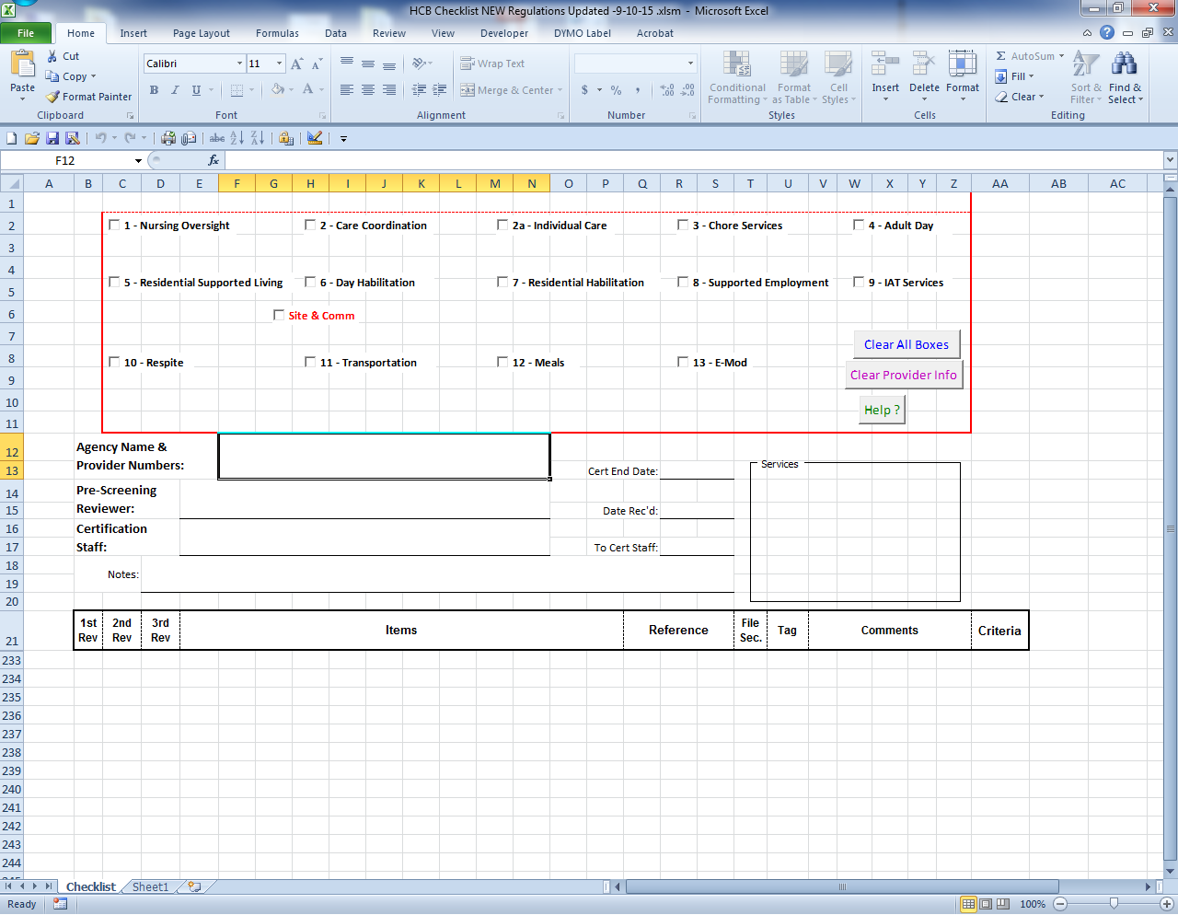

1. An example of what happens when you click a service box
   1. Choose Initial or Recert

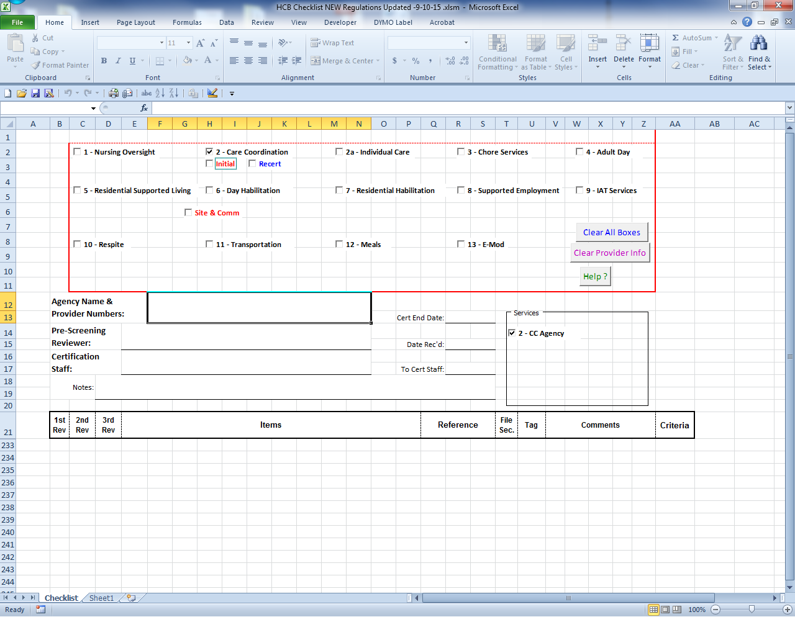

1. Frequently additional options will come up based on the service

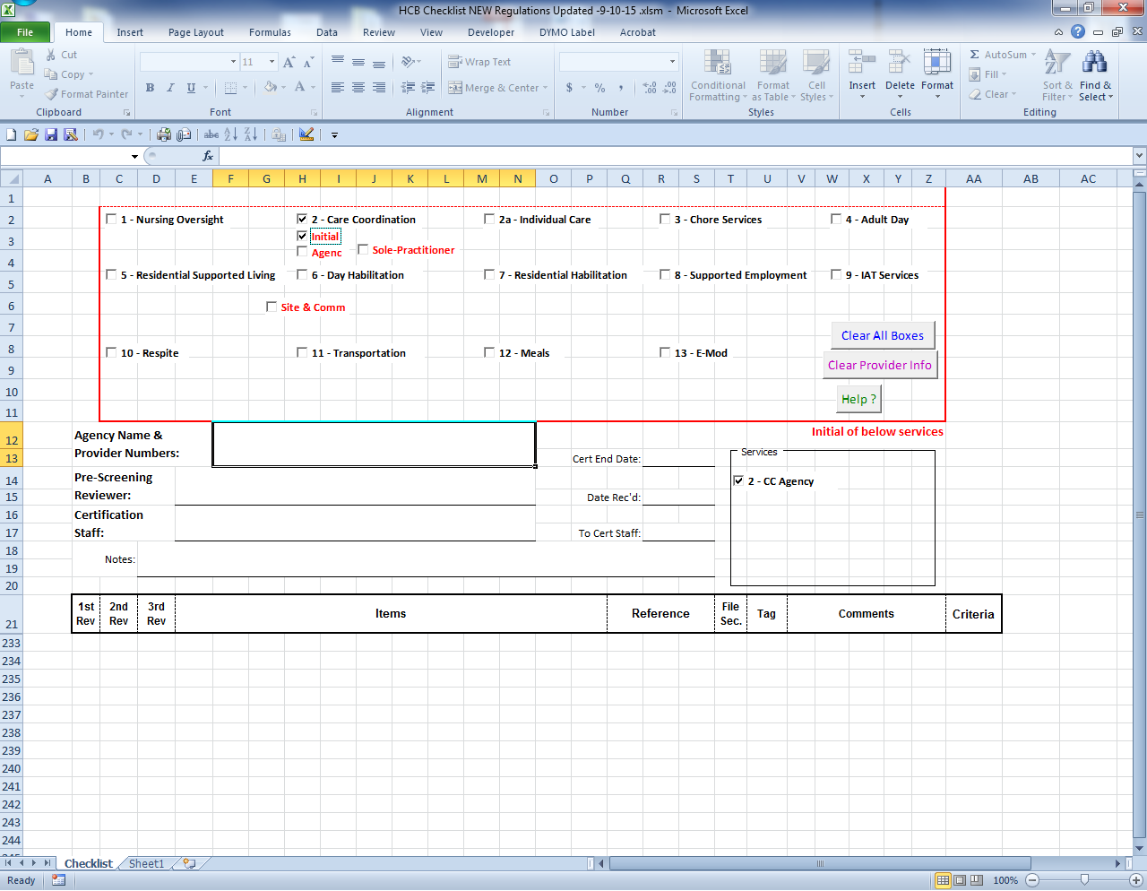

1. Once all the layers of choices are clicked the rows below will show up with the requirements for that service. If more than one service is chosen then more items will show on the list but each requirement will only show once.

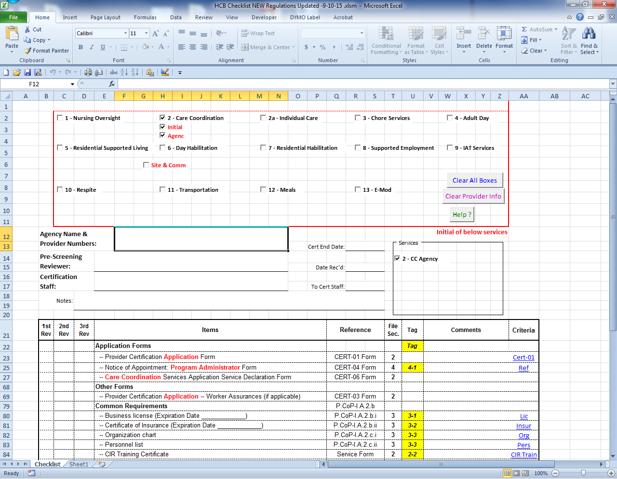

1. Recertification is a similar setup

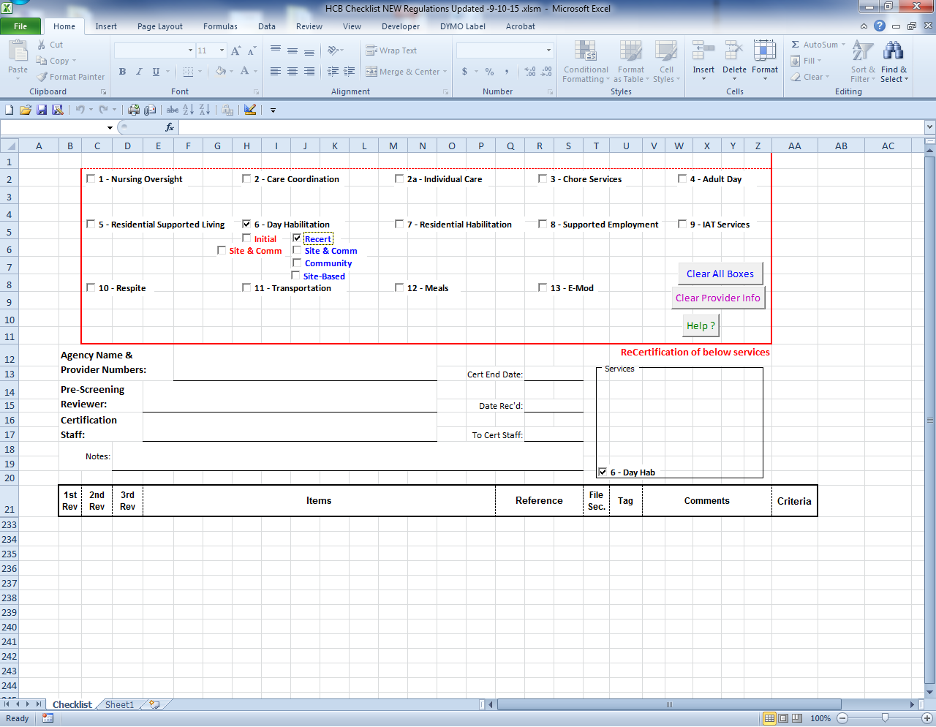

1. After the service(s) are chosen simply enter the needed information
   1. Agency Name and Number (124567 or CMGAPP or HCX etc)
   2. The end date if it applies
   3. The date received
   4. Who the application is being assigned to
   5. The date it was given to the staff member
   6. Any notes regarding the provider or application

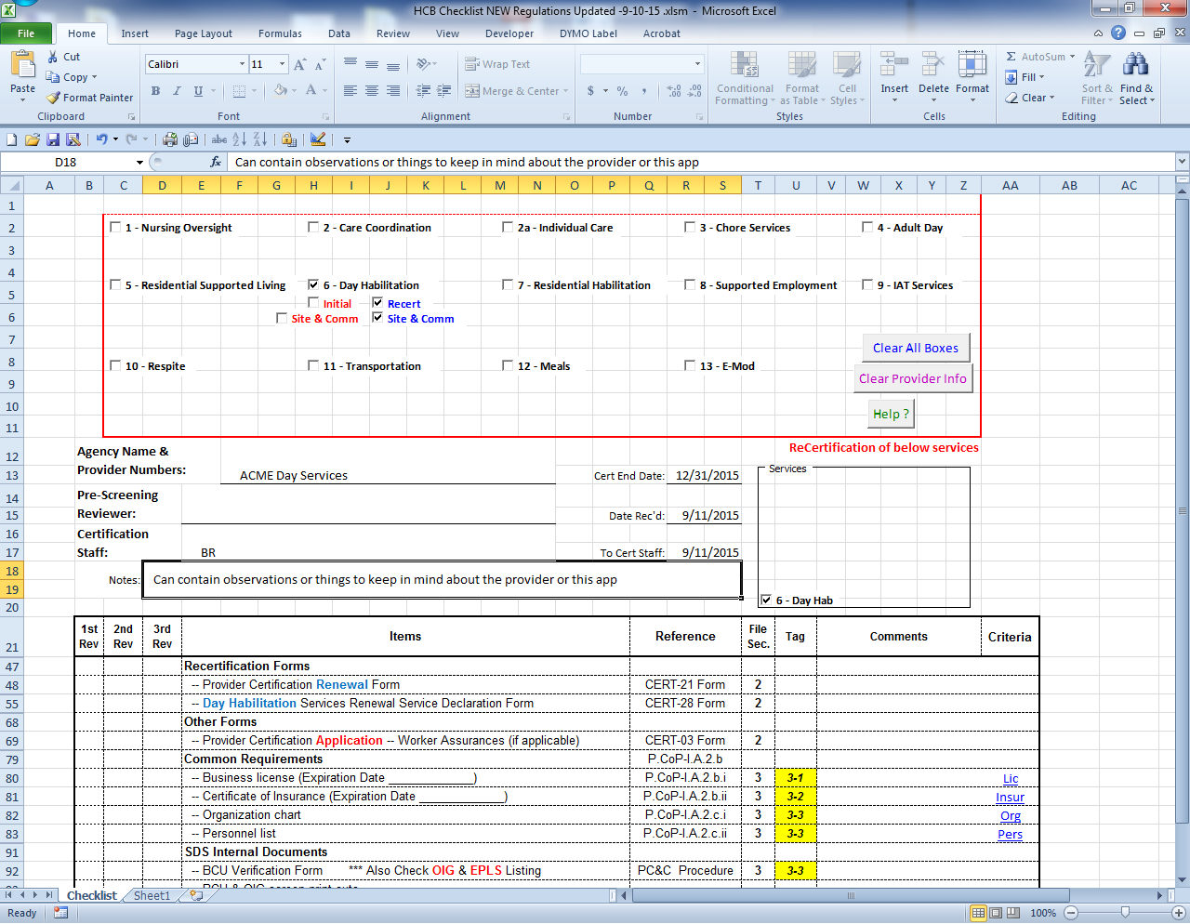

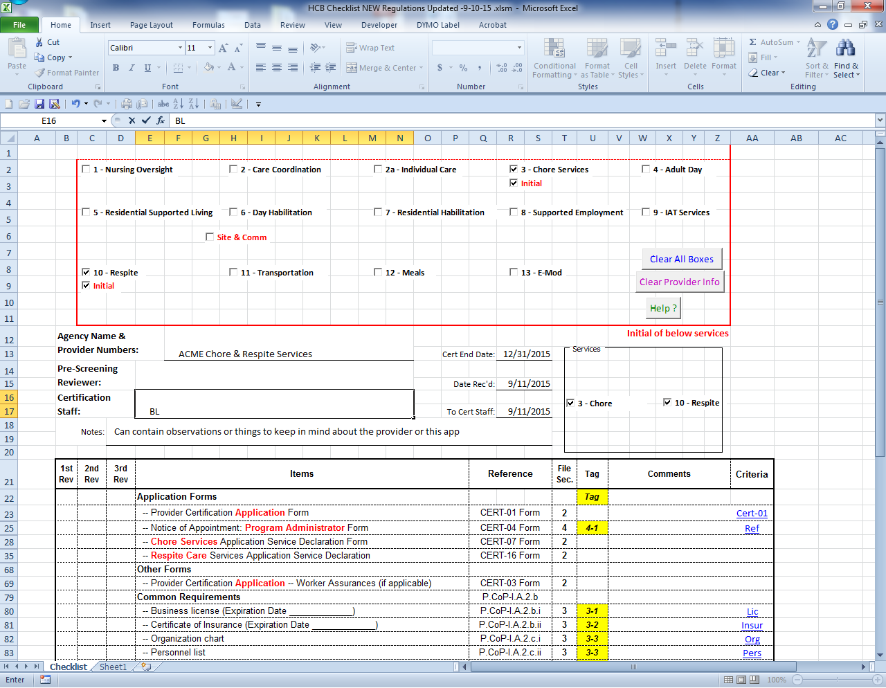

1. Print the checklist to include it with the application

## PCA

PCA Cert Folders Checklist - 11-7-2013.xltx

This checklist is a much simpler template without the automatic show and hide of rows features of the Waiver checklist.

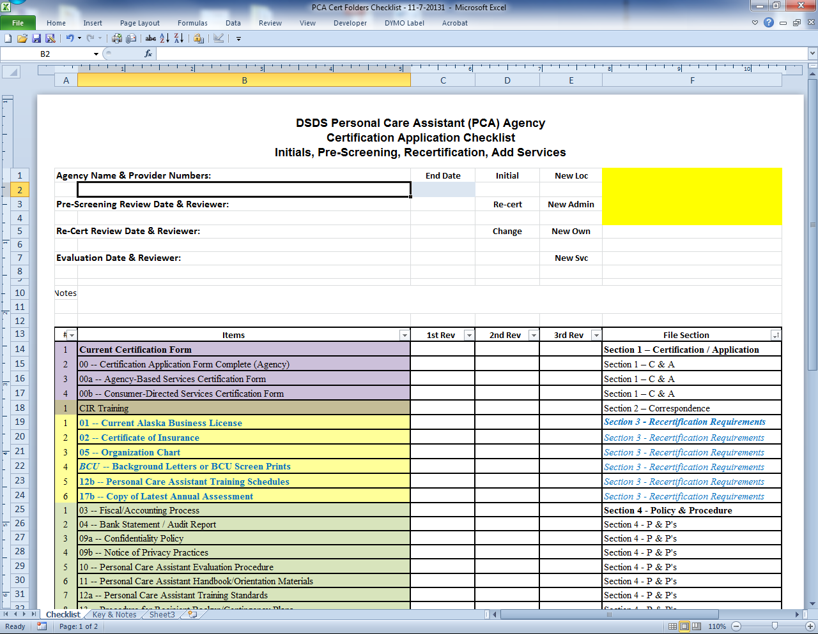

1. Fill in the boxes
   1. Provider Name and number (sometimes location is helpful for large multi-site agencies)
   2. End date
   3. Put an “X” in the right box for the application type
   4. Add the date it will go to the worker
   5. Add the initials of who it is assigned to
   6. Any notes regarding the application

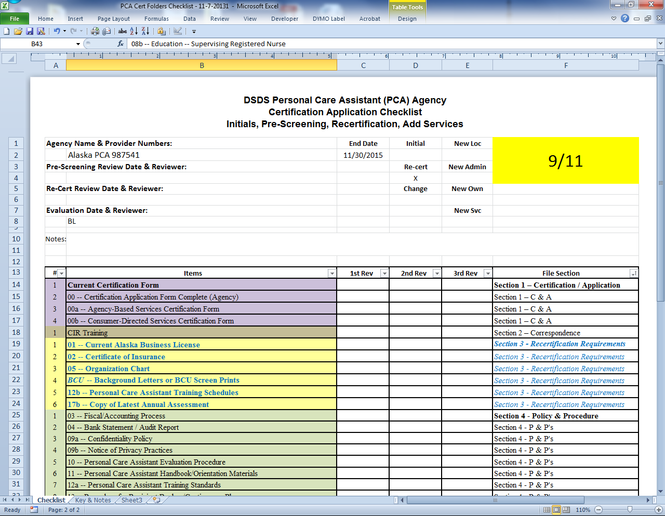

1. For recerts especially simply highlight and hide the rows that are not needed

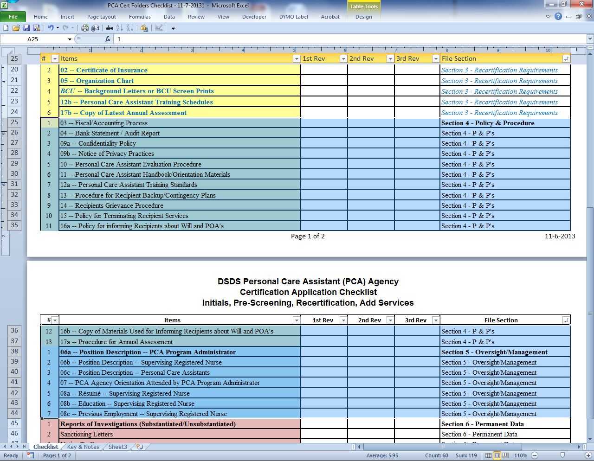

1. Right click to get the pop up menu for hiding rows



# Electronic Folders

1. New folder
   1. click new folder

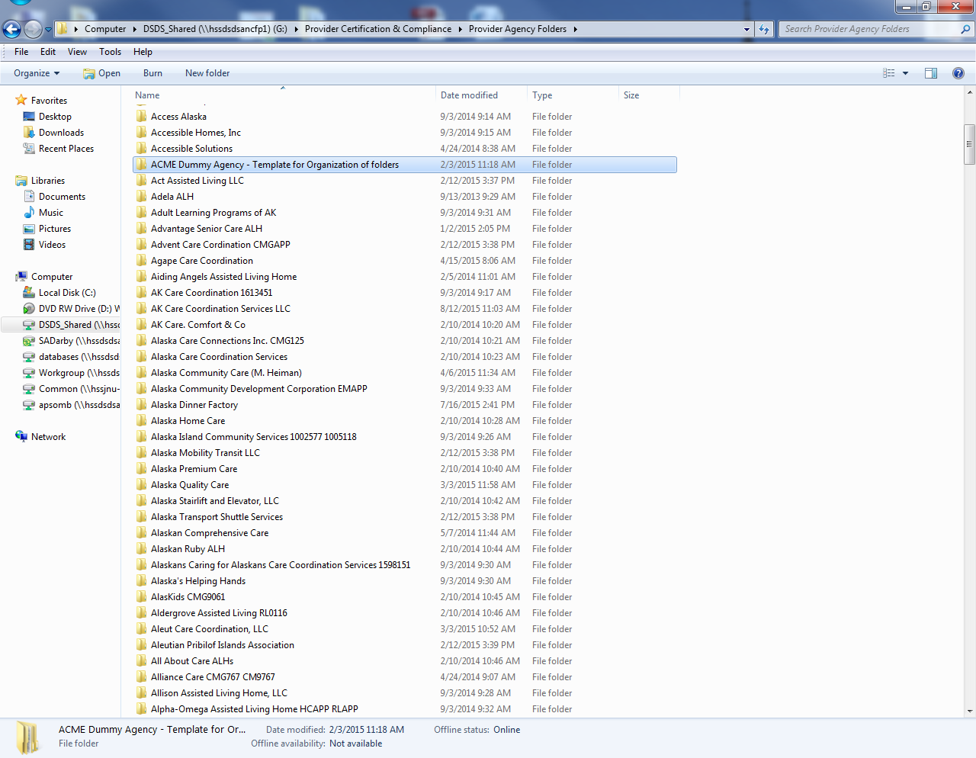

1. Copy paste from ACME folder
2. Folder list and what should go in each

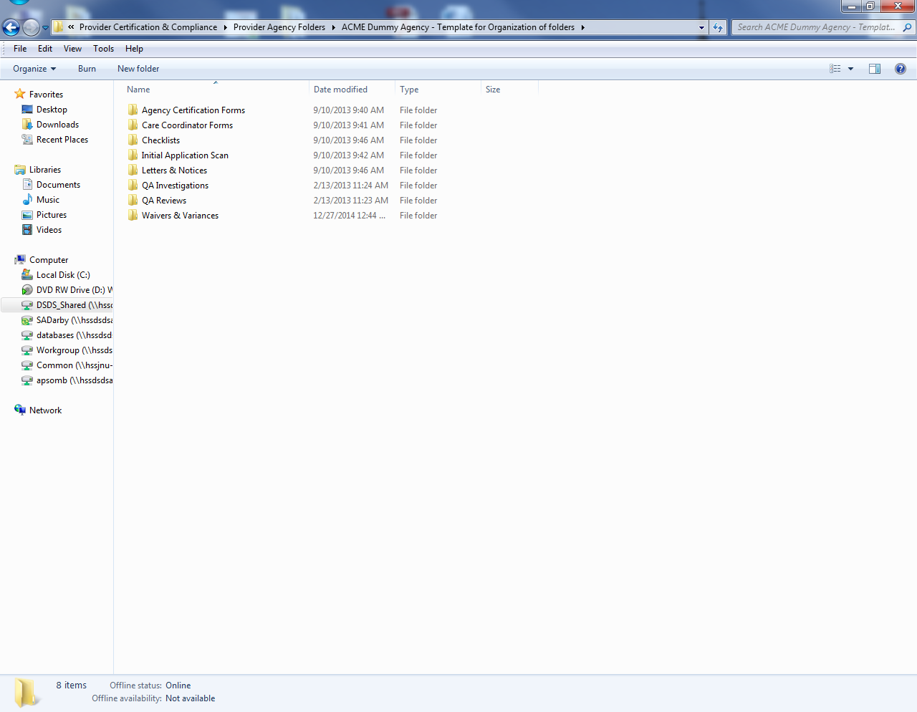

1. Additional folders



# New BCP Account

* For initial applications, send e-mail to the Background Check Program unit and request an account be established.
* Needs to be updated with instructions for new form and process

# Approval Review Process

What are the key elements of the approval process?

Need to remove all the DS3 bits and/or move the process bits to the right places?

## Prioritization

* Recertification applications take priority over initial agency applications (unless otherwise specified). They are due, by regulation, no later than 60 days prior the existing certification end date.
* Agencies will be recertified prior to the end date of their certification if complete applications are received and evaluated prior to the end date.
* Place the applications in your queue according to date received and/or certification end date. They will be worked in the order received and all attempts will be made to complete certification within 30 days, per SDS Provider Certification policy 12-1.
* Initial Care Coordinators for established care coordination agencies will be processed within 2 business days.
* Residential facilities where there are waiver recipients currently residing in the facility and would like to remain. Example: an application from a new owner or previously “GR only home” will be prioritized.
* Added services for currently certified agencies if it is to address an underserved population or area may be prioritized.

What about initial agencies in underserved areas?

Break the following down into sections as appropriate

## Additional Locations, Multiple Locations and Multiple Services

* Determine if request is for additional service or location or if it is an entirely new application:
  + Multiple Locations: Agency name will be checked against records to ensure that if there is more than one location that needs to be certified that the agency submits an application for each individual location.
  + Multiple Services: An agency may apply for more than one service within one application or add a service with a new application; the application must include the complete requirements under each section type (or in the section for the new add-on service).

## Beginning a Review

* Using the certification application checklist and the certification application instructions, carefully read through all submitted documents of the application to determine if all required contents are present.
* If required documents are missing or if a policy and procedure lacks the minimum required content as stated in the instructions, flag that section for future reference when writing the “pend” notice and leave that box on the checklist blank.
* For each required document that is submitted and is complete and accurate, write your initials in the box on the certification application checklist that corresponds to that document. If the item listed on the checklist is not applicable to that service type or provider, written “NA” in the box. (Example: Worker assurances form, personnel list, etc”).

## Checklist use

* Mark your initials in the box that corresponds to the required item or document once received. The goal is to have your initials appear in every box on the certification application checklist form, or the application will not be approved.
* The application will not be approved until your initials appear in each box on the certification checklist.

### Pend Letters

* If there are missing/insufficient documents and items, use the “Certification Pend Letter Template” to document what is missing and provide a due date to submit the required documents (10 business days).
  + Immediately save the pend letter to the agency folder on the G Drive using the ‘save as” option so that others may use the template if needed.
* Once completed, save the letter as a PDF and email it to the applicant or provider using the “Delivery receipt” and “read receipt” options.
* Use numbers to list the required missing documents and items in the pend letter.
* If you send a pend letter after the first pend letter because the provider or applicant only submitted partial information or more clarification is needed, use the “Certification Pend Letter Template” and change the wording so it is clear that it is a subsequent pend notice.
* SDS Policy 12-1 states that applications for certification must be completed within 30 days of the first “pend” letter sent to the applicant by SDS. Once this 30 day time period is reached, a final determination of certification status must be made.

### DS3 Notes

* Use the DS3 note “Provider - Certification – Information Requested for Application Evaluation” and cut and paste the portion of the letter that explains what is missing in the application or what needs clarification into the DS3 note field.
* As additional and/or previously missing documentation is received by applicant they must be date-stamped and placed with the application.
* If the agency fails to respond contact them for follow-up and note correspondence or attempts to contact them in DS3.
* As you correspond back and forth with the applicant or provider, make notes in DS3 using the appropriate note titles such as “Provider – Provider - Contact” and “Information received” so that there is a record of correspondence on file.

### Special Notes

* Special note about Medication Administration and Assistance with Self-Administration of Medication (ASAM) training curriculum: Regulation 7 AAC 130.227 lists provider types that are required to offer medication administration as part of their service. Therefore, they must have an approved training. For Medication Administration, they must use the Board of Nursing (BON) training. For ASAM, they can either develop their own training curriculum which must be submitted to SDS for approval or their can use the Trust Training Cooperative (TTC) training which has been approved by SDS. When you receive an ASAM training curriculum forward it to the SDS training coordinator for approval. Once approved, complete the “ASAM Approval letter” and send to provider, keeping a copy in their folder.
* Enter a separate DS3 note called “ASAM Training Approved” once the training curriculum is approved.
* Special note about new Program Administrators: You must ensure that the completed “Notice of Appointment: Program Administrator” form is submitted, that three references are listed, and that the resume and educational qualifications are submitted and meet qualifications as set forth in the regulations and COPS. Call at least two of the listed references and use the Program Administrator reference check form. Include the two completed forms in the final packet.

### Extensions

* An extension of the certification application review period may be granted allowing additional time to complete the requirements if the following criteria are met:
  + The pend due date is after the certification end date.
  + The provider is unable to resolve the issue(s) prior to the certification end date.

## BCU & verification form

* Log into the Background Check Program (BCP) database and print out the agency’s BCP account.
* Compare the BCP account listing to the agency’s organization chart and personnel list.
  + Ensure that all names listed on the organization chart and personnel list appear in the BCP account with a BCP status of “Provisional” or “Permanent”.
  + If a name does not appear on the BCP list do a “person search” in the BCP database. If they appear with an “incomplete”, “in process”, or “note eligible” status, this information must be included in the pend letter to the agency, reminding them that the individual may not have access to Protected Health Information (PHI) or recipients until the status is “provisional” or “permanent”, or until the individual receives an approved background check variance. SDS requests that for any “not eligible” status individuals that appear on the agency’s BCP account, the agency submit a brief statement in writing that they will remove the individual from PHI and recipients immediately until the BCP status is “provisional” or “approved” or until the individual is granted a variance.
  + If a name appears in the BCP account as “terminated” or “withdrawn” and is not on the personnel list or organization chart, that is acceptable; however, if they are still on the organization chart, include that in the pend letter and request clarification and/or corrections as appropriate.
  + If a name appears in the BCP account with an “approved” or “provisional” status but is not on the organization chart or personnel list, include a request for clarification in the pend letter.
  + Refer to BCP regulations to determine which roles and job positions must go through the background check process. Essentially, anyone who has access to recipients (whether waiver or not), PHI, or unsupervised volunteers must have a valid criminal history check.
  + Once the BCP account completely matches the organization chart and personnel list and all BCP statuses in the agency’s account are “provisional” or “permanent”, print out the Background Check Verification Form, sign and date it, and include it in the application packet.
  + Special note about contracted family habilitation and/or group homes:When a certified Residential Habilitation agency contracts with a home to provide group or family habilitation services, we must ensure that the owners and all employees of the home, which must be licensed, have valid criminal history checks. This will entail checking that particular home’s BCU account as they will likely not be listed in the certified agency’s BCU account. Once the new background check system is implemented, the certified Residential Habilitation agency will be expected to “affiliate” each contracted home with their account. For now they are usually separate and must be verified by us when certifying or recertifying the agency.

What should happen when an agency adds a new home mid-certification period?

## Exclusion lists

* Check the status of the agency owners and/or board members in the following systems to identify any outstanding issues that would preclude moving forward with certification:
  + **OIG Exclusion Checklist** for any owners, board members, or others not already entered in the Background Check Program account for the agency(if agency is on this list, the application will be denied and returned with a letter regarding the OIG Exclusion)
  + **State of Alaska exclusion list** for any owners or others not already entered in the Background Check Program account for the agency(if agency is on this list, the application will be denied and returned with a letter regarding the State of Alaska exclusion list). This list is posted on the Program Integrity Unit’s website.

## Licenses

* + **Licensing:** To verify any licensure required such as Assisted Living Home, dietician license, nursing license, contractor license for Environmental Modification, etc.)
* If the applicant or provider is an IAT service provider, ensure that the person delivering IAT services has one of the following degrees, certifications, or licensure:
  + Marital and Family Therapy
  + Psychologists and Psychological Associate
  + Social Workers
  + Special Education Teacher
  + Applied Behavioral Analysis professionals

## Car Registration

Check the dates of the vehicle registrations

## Care Coordinators and Care Coordination Agencies

Info on CFCC???

When certifying or recertifying care coordination agency applications, make sure that individual care coordinators are also recertified if their recertification’s are due.

### Care Coordination Agencies (Sole Proprietor)

* Administrative Support Staff: Copy the form, resume, and training documents for their individual care coordinator file, clip separately, and leave a copy with the agency folder. All care coordinators (including program administrators and care coordinator of the independent care coordination agency) have a manila file folder with their name which are filed in the Care Coordination drawer.

**Multiple Agencies:** If a care coordinator works for multiple agencies, they must be affiliated with each agency. An application from each agency is required but there is no need for the individual qualification documentation to be resubmitted. The application will be processed and approved with a new certification form, affiliating that care coordinator with the second (or more) agency.

* A new DSDSID record will be set up in DS3 for the care coordinator to be associated with the second agency. The name of the care coordinator will have the name of the agency added (e.g.”Bovey (Safe Haven Care Coord), Theresa”). The care coordinator maintains the same provider number.
* Once approved, an amended cert form is created, affiliating the care coordinator with the second agency, and there will be a note on the certification form indicating it is for “a second agency” and must list the name and provider number of the second agency.
* The second application and certification are processed just like the initial one and kept in the same file.

## Hab Homes

* If the applicant or provider is a Residential Habilitation service provider that owns or contracts with family habilitation homes or group homes, ensure that each home affiliated with the certified provider agency has a valid and current license for the home.
* If the applicant or provider is a residential setting provider (Residential Habilitation, Residential Supported Living), ensure that the license of the facility
  + is current
  + is appropriate to the service type they wish to provide and be certified in by checking the type of license (SS or MHDD, dual, or SS or MHDD with a variance for an individual person outside the scope of the license).
  + has appropriate capacity for the service type to which they are applying. Example: If applying for Residential Habilitation - Group Home, the license must show that they have capacity for 2 or more residents.
  + MHDD license - issued to a home providing care primarily to persons with a mental or developmental disability
  + SS license - issued to a home providing care primarily to persons who have a physical disability, who are elderly, or who suffer from dementia, but who are not diagnosed as chronically mentally ill

|  |  |  |
| --- | --- | --- |
|  | MHDD License | SS License |
| Residential Habilitation | IDD, APDD, CCMC over 18 |  |
| Residential Supported Living | APDD, ALI | ALI, APDD* (*if dually licensed or if a variance has been approved) |

Do we want to add the Hab Homes Connection process here?

## Respite/Day hab

Dates

## Approvals

* Certification staff completes an Initial Certification form. The certification form is completed as follows:
* Start date is the date that the certification staff person received a complete application that meets SDS minimum standards and has made a final determination that applicant is a qualified provider. **Certification start dates are never backdated.**
  + End date will be the last day of the 11th month from the month of start date (example: start 09-16-09, end 08-31-10) for initials
  + If recertification, the start date will be the day after the end date of the previous certification. The end date will be 2 years less one day from the month of the start date (example: start 09/01/09, end 08/31/11).
  + If the agency was an extended recertification, the end date is what the original end date would have been had they not been extended.
  + If an ALH’s license expiration date is the same as the certification end date, extend the certification end date by one month.
  + Type of waiver programs and services must be marked with a “Y” based on the services that agency applied for and is eligible for. PCA certification is checked either for CDPCA or ABPCA or both.
* The certification form is printed out and signed. The certification form is never handwritten. Two copies are made;
  + - Original mailed with approval letter to agency
    - Copy for the provider file
    - Copy to be placed in box in copier room. It is emailed to Xerox each week by Certification Supervisor and key SDS program staff are cc’d.
* Certification staff updates DS3 with note title “Certification – Application Complete”.
* New provider/care coordinator information is entered in DS3;
* Under Medicaid codes change service from (example) “RLAPP” to “RLX” and change status to “Certification –Pending Enrollment”.
* The start and end dates are to be placed in the service category section; once the billing number is assigned by Xerox, enter the start and end date into the date fields on the front page.
* Service Category must be completed including “Core Waiver/PCA” and for each individual service.
  + Contacts must be entered, including owner and any administrators, designee, and HR manager.
  + Affiliate Care Coordinator(s) to the CMG.
  + Notify Administrative Support Staff of any family habilitation and group home providers to be affiliated with Res Habilitation providers.
  + Enter DS3 case notes
* Certification staff compiles the application, with the completed checklist as a cover sheet, BCP verification form, and other documentation and tabs the application sections using the pre-printed tabs according to service type.
* Complete and tabbed packet is given to Administrative Support staff for folder assembly and filing
* Hard Files: New agency file is assembled using the standardized folder format and filed.
* Xerox sends a weekly report of new and inactivated providers. Update DS3 with these changes.
* Communicate the changes to Certification Supervisor, Prior Authorization staff, and Program Staff if appropriate.
* Save this report to G drive under databases/provider database/Xerox report.

## Filing

* New hanging folder and name tag created and placed in file cabinet by support staff;
* Electronic Files: Completed application and the signed certification form are scanned and saved to the agency electronic folder.
* Place in the To Be Scanned box in the copy room
* All agencies are scanned in as many parts as needed
* Each care coordinator and agency are scanned separately

# Approved Providers

## Details Tab

Activate the provider

## Contacts

Backup CC

Program admins

Owners

## Categories of Service (Medicaid Tab)

### All Agencies

1. For initially certified new care coordinator or agency:
   1. Remove the “APP” and enter an X (CMX). This is a placeholder until a provider number is issued.
   2. Leave the start and end dates blank
   3. Change the status to “Inactive – Certified but Enrollment Pending”
   4. Click Save

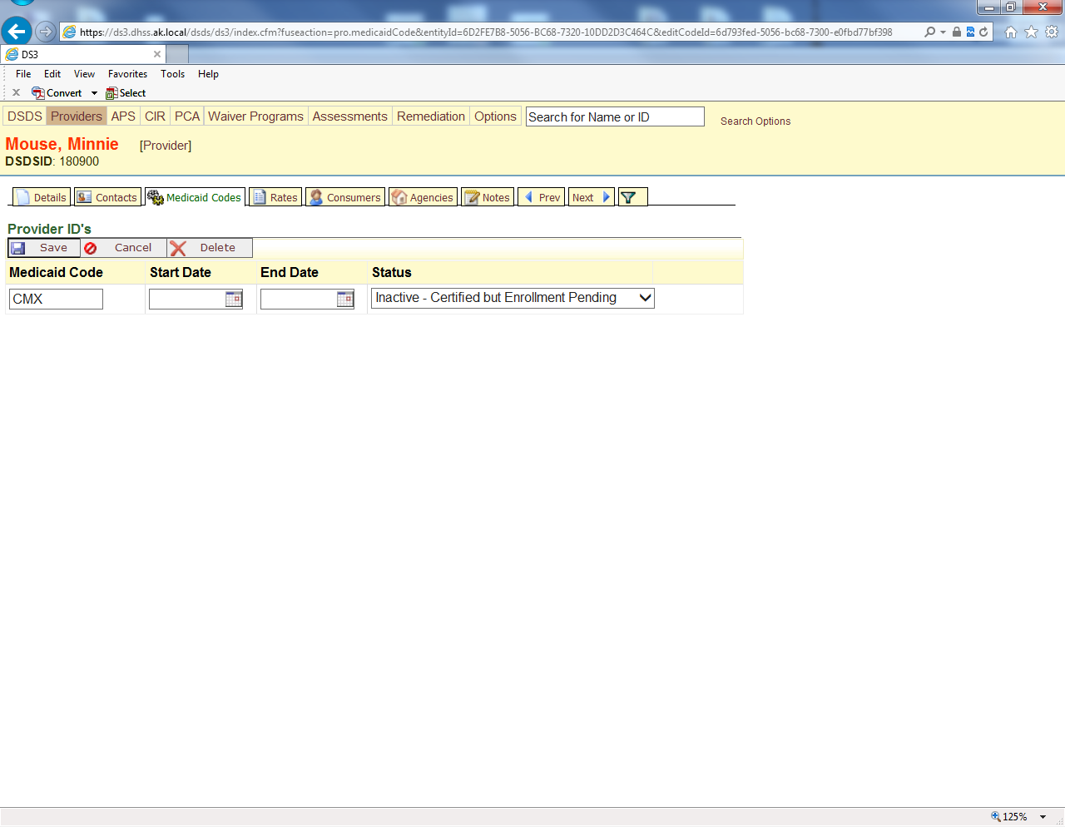

1. Under Service Categories click on the “Click here to add one now” link

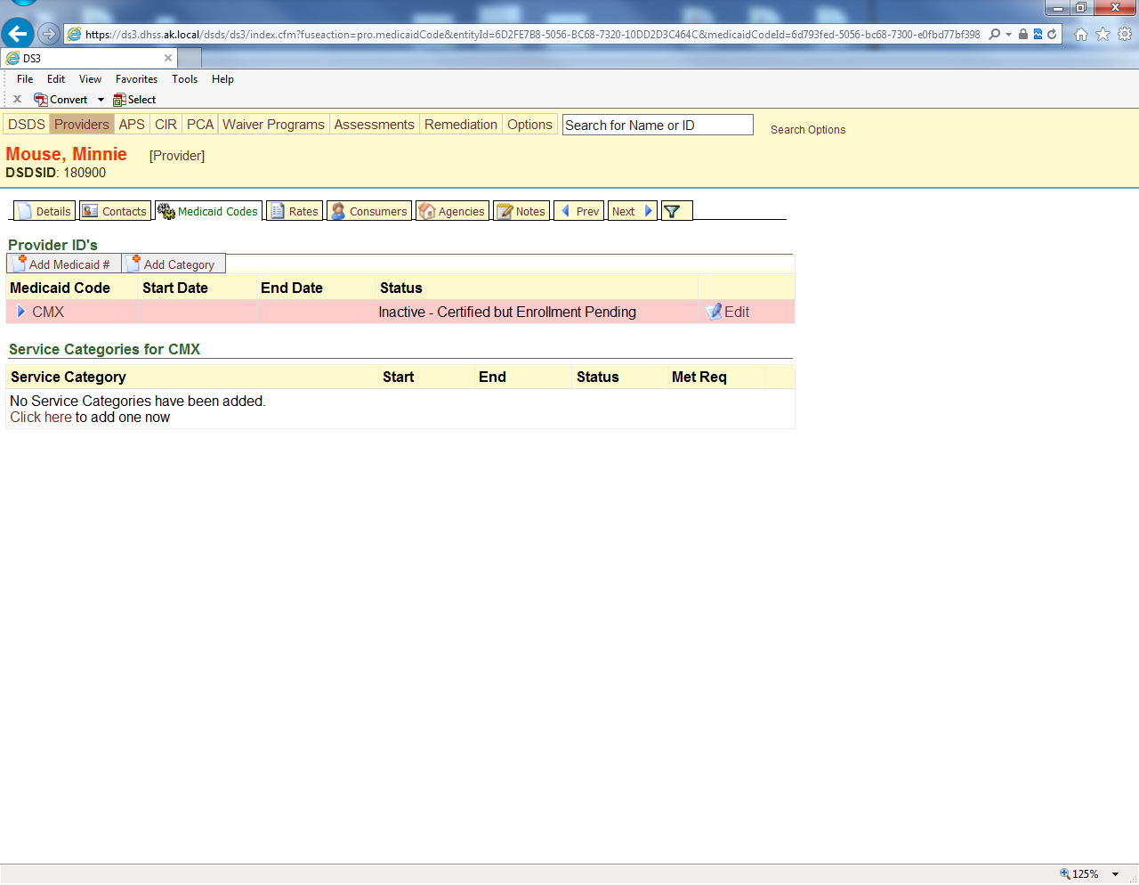

1. Choose the COS (Category of Service)

### Care Coordination (Individual)

* + 1. COS – Care Coordination (Individual)
    2. Add the status (Inactive – Certified but Enrollment Pending)
    3. Add the start and end dates of the certification
    4. Choose the type of waiver clients to be served
    5. Save

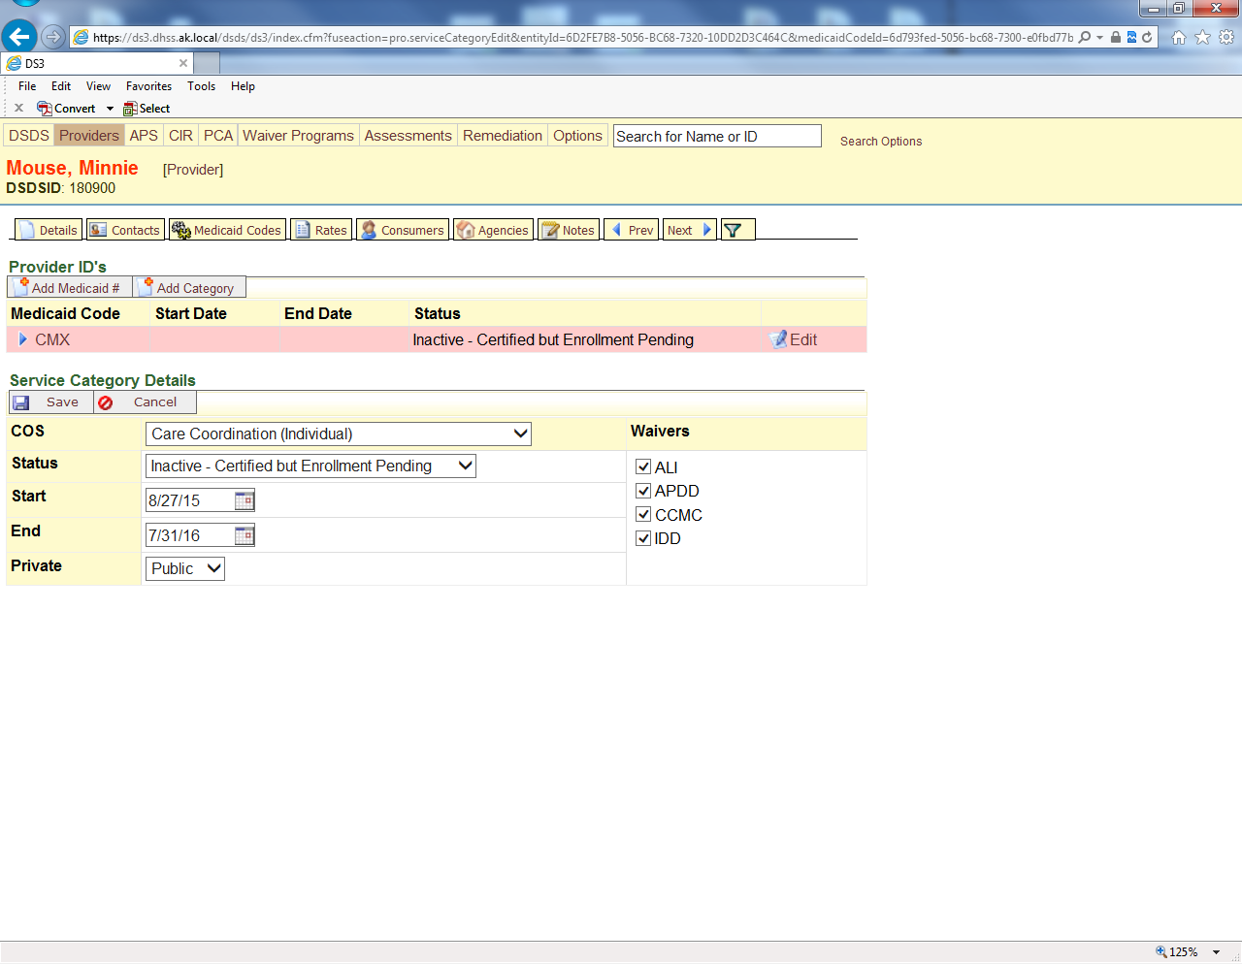

### Care Coordination (Agency)

Core waiver

### PCA

AB or CD on front page

As a service type

### Respite

Dates

Types family or plain

### Day Habilitation

Dates

Site or community

### Residential Habilitation

The 4 types

Front page licenses

Types and Link between home and agency

### RSL

Types and licenses

### All other services

Core waiver

## https://cdn0.iconfinder.com/data/icons/trio-miscellaneous/32/reminder-3-512.pngLinking Providers Care Coordinators and Residential Habilitation Homes

Notes on how to check affiliation, where to find the renderers vs agencies one is hones attached to the HC that is certified and the other is the agencies a home is attached to

### Agents, Agencies and Renderers

1. To link a Care Coordinator to an Agency go to the Agencies tab (applies ONLY to Care Coordinators)
   1. Click “Link to Provider”
   2. Search by Agency Number and choose Care Coordinator

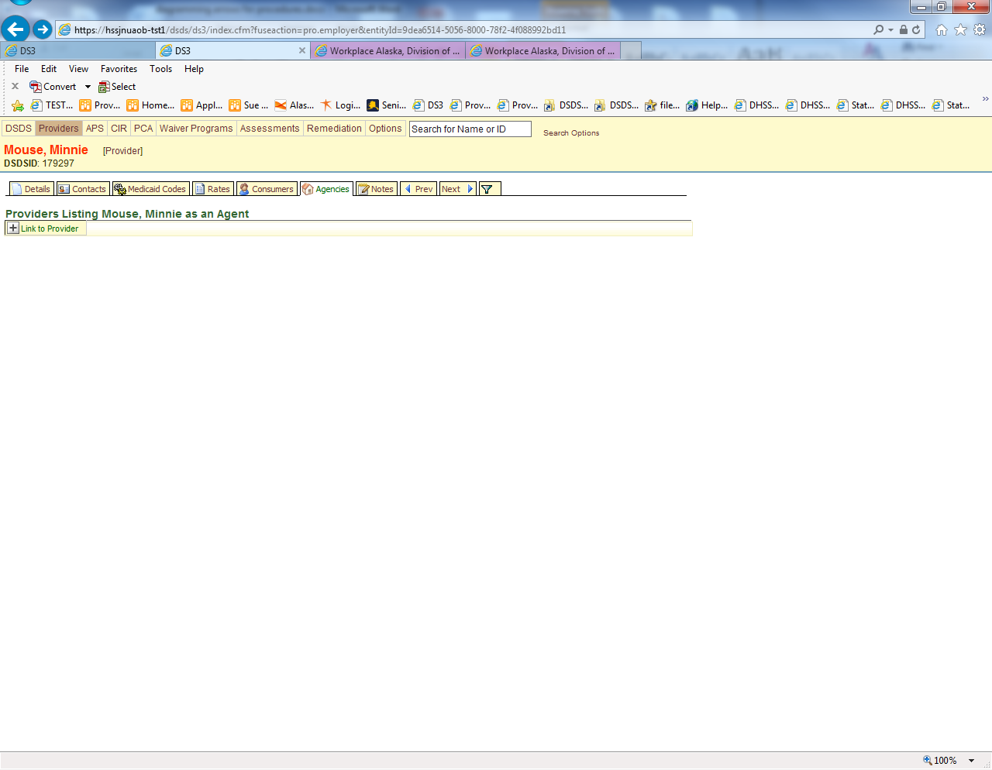

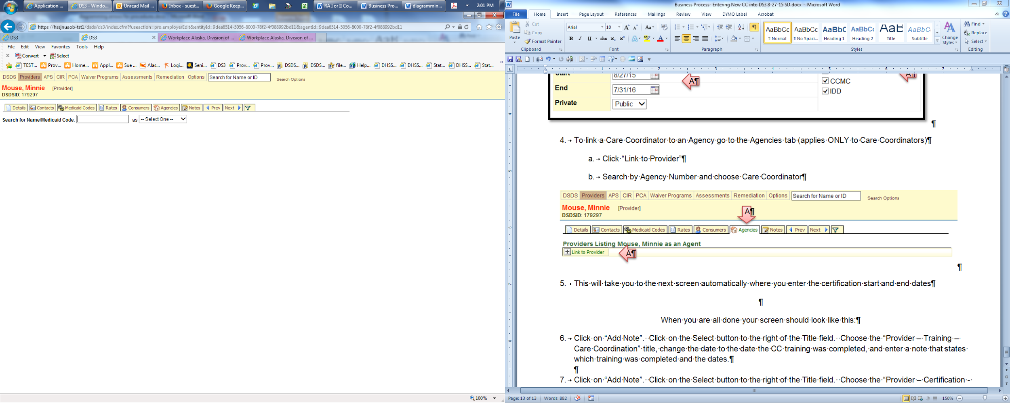

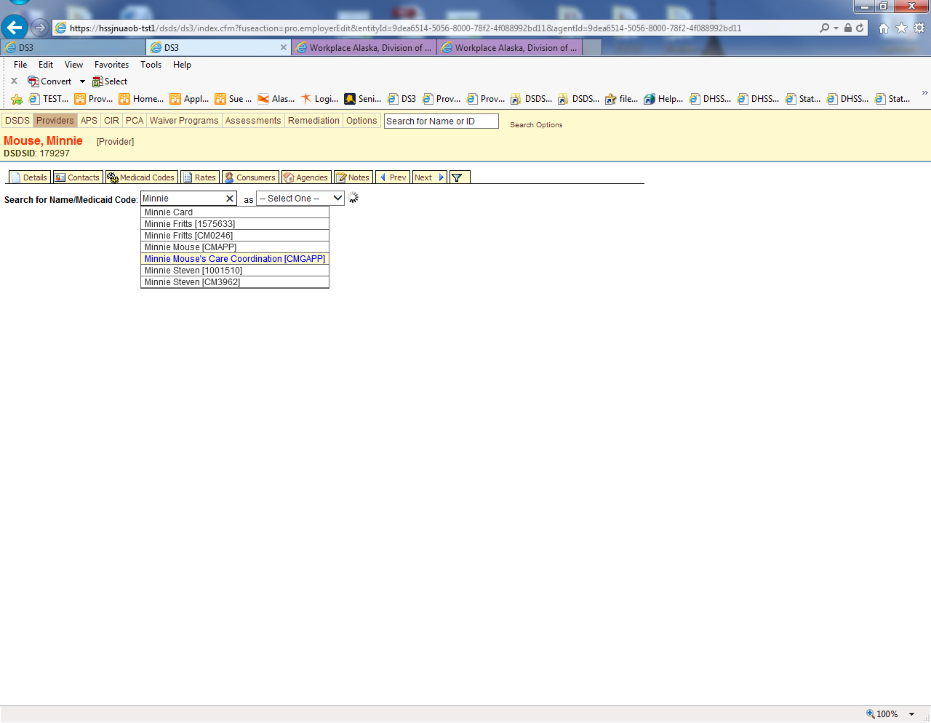

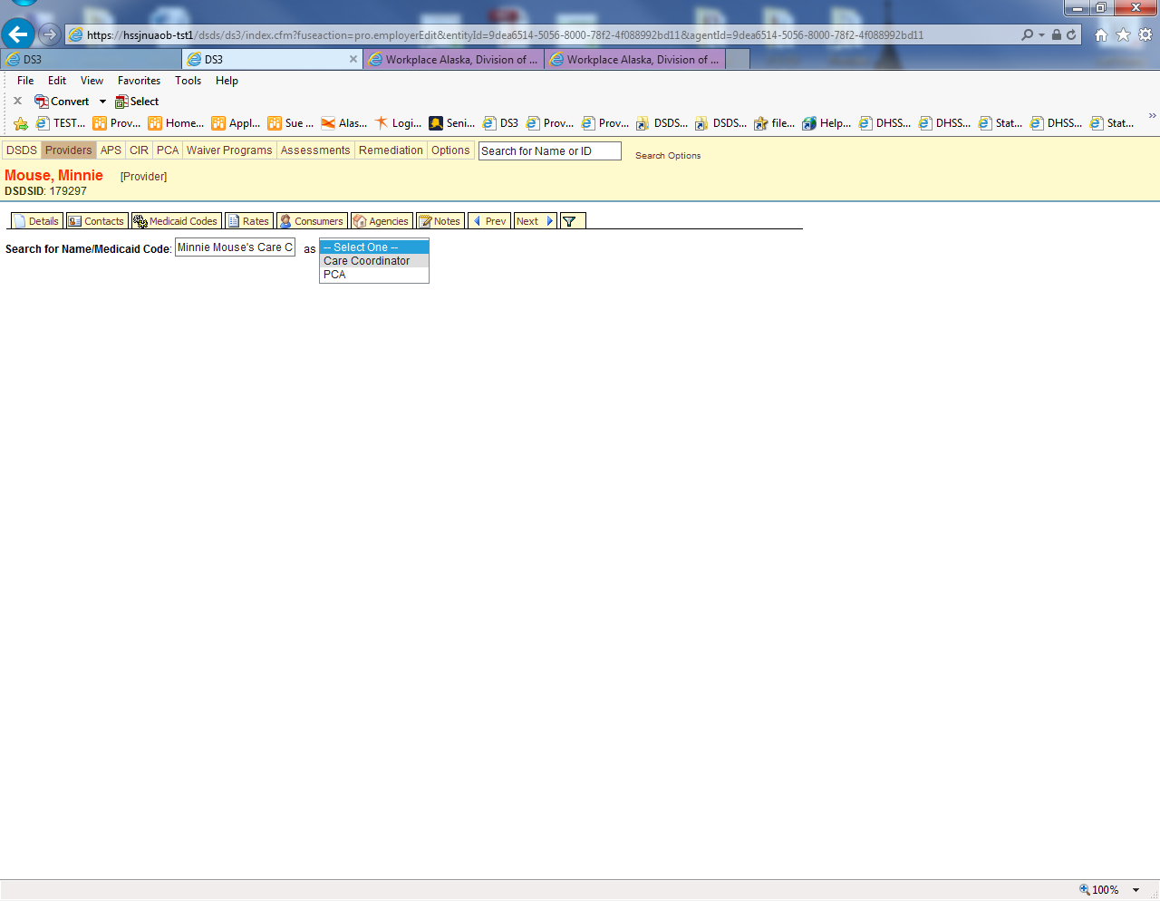

1. This will take you to the next screen automatically where you enter the certification start and end dates

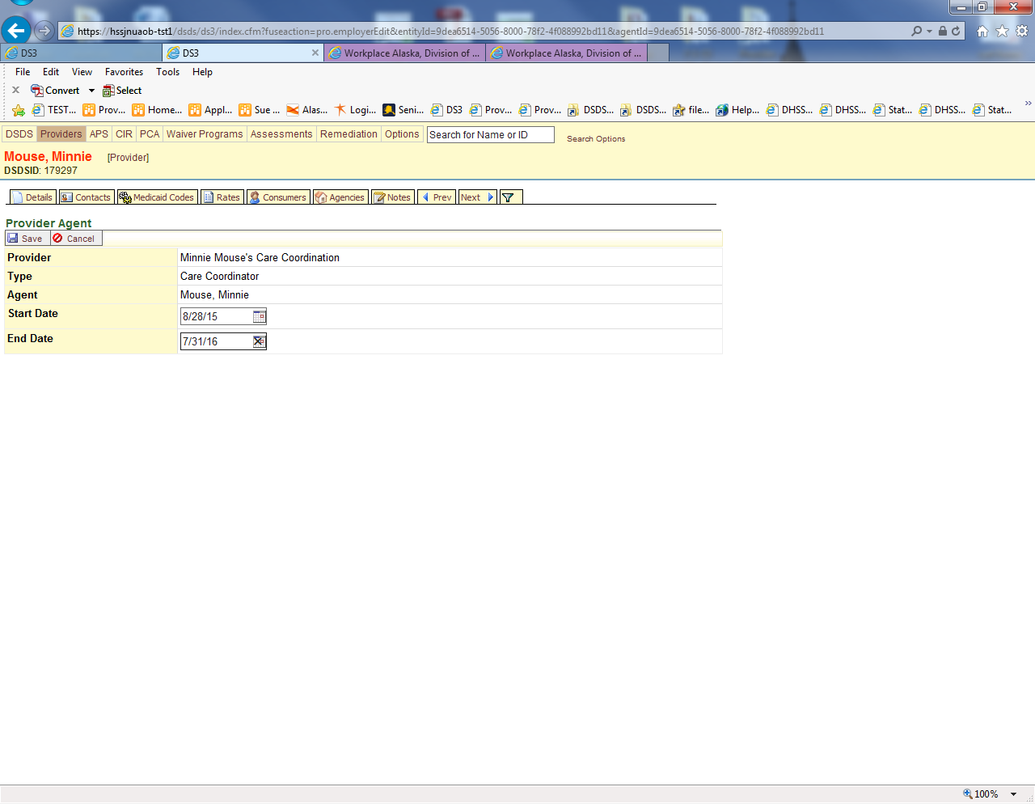

When you are all done your screen should look like this:

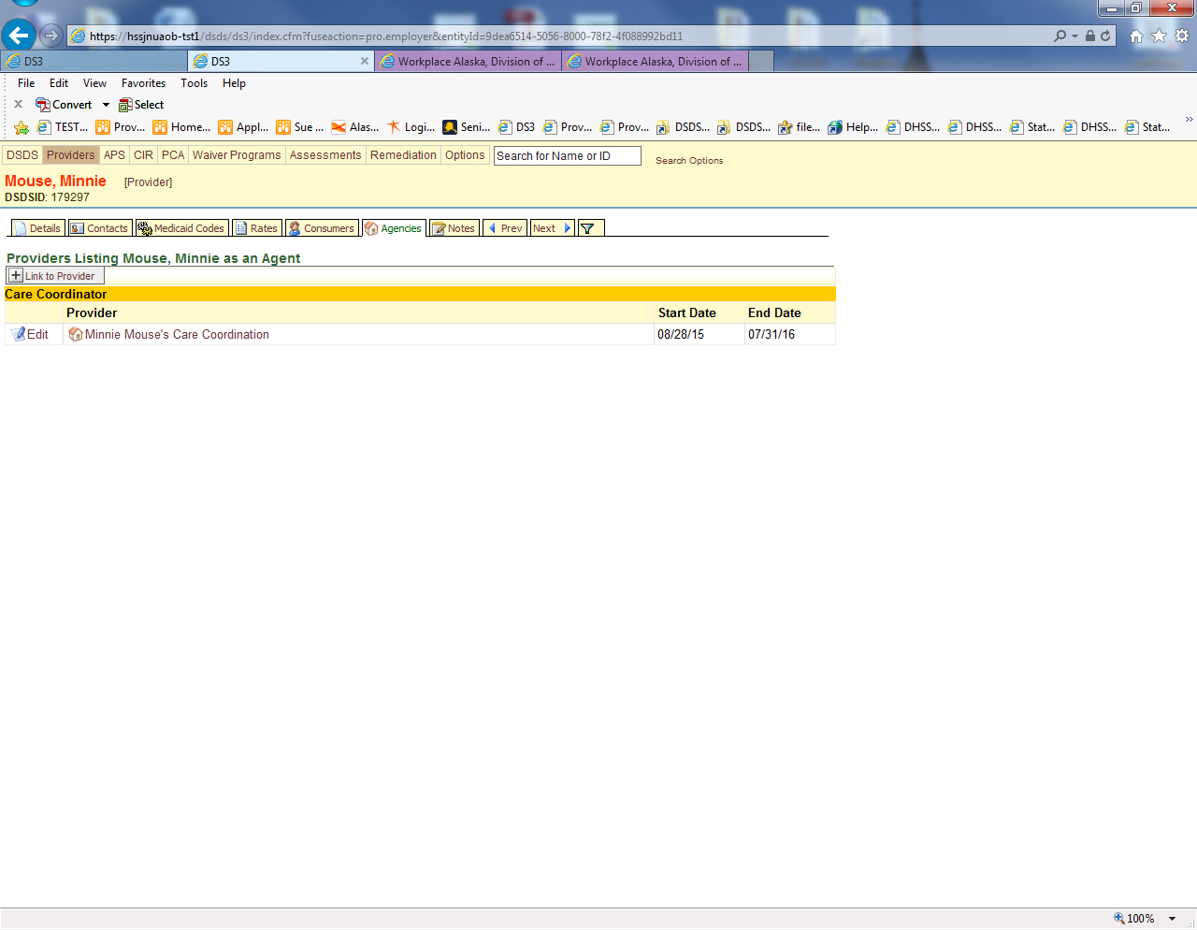

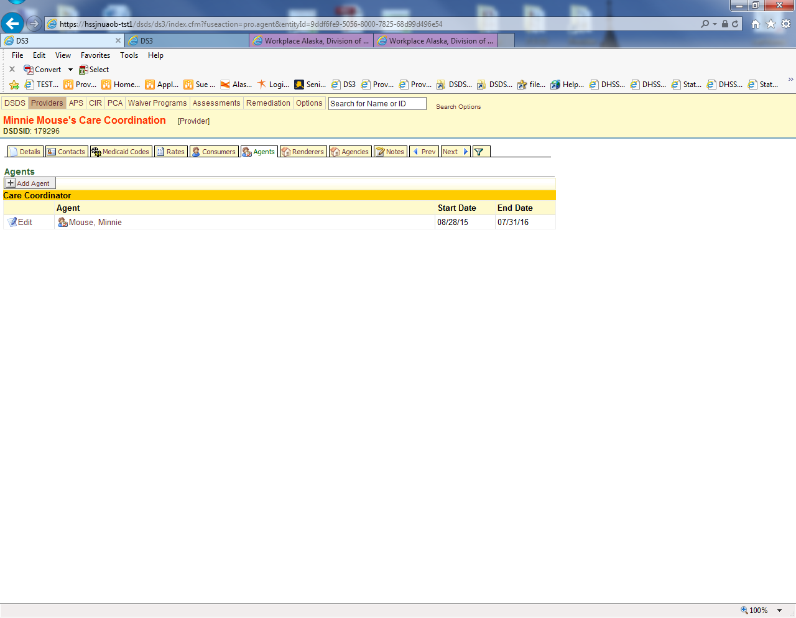

# https://cdn0.iconfinder.com/data/icons/trio-miscellaneous/32/reminder-3-512.pngNotes

## Care Coordinators

1. Click on “Add Note”.
   1. Click on the Select button to the right of the Title field. Choose the “Provider – Training – Care Coordination” title
   2. change the date to the date the CC training was completed
   3. enter a note that states which training was completed and the dates.

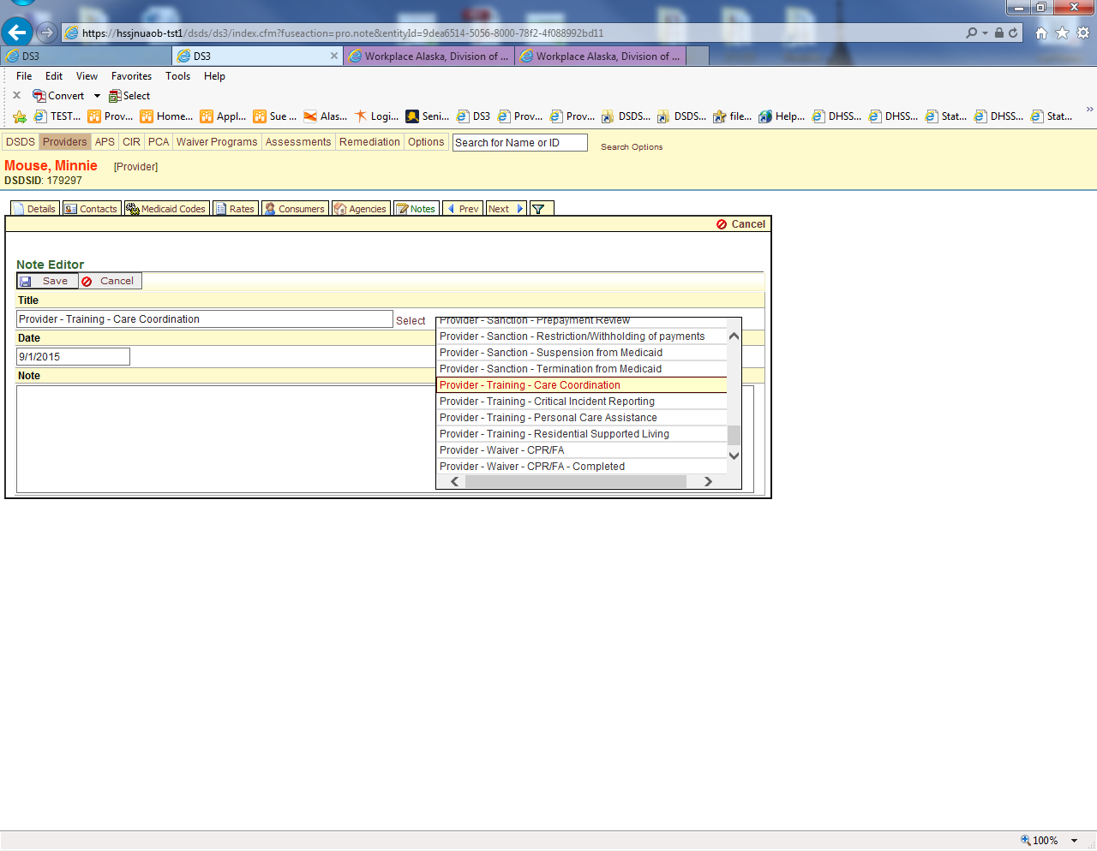

## All Providers

1. Click on “Add Note”
   1. Click on the Select button to the right of the Title field. Choose the “Provider – Training – Critical Incident Reporting” title
   2. change the date to the date the CIR training was completed
   3. enter a note that states which training was completed and the dates

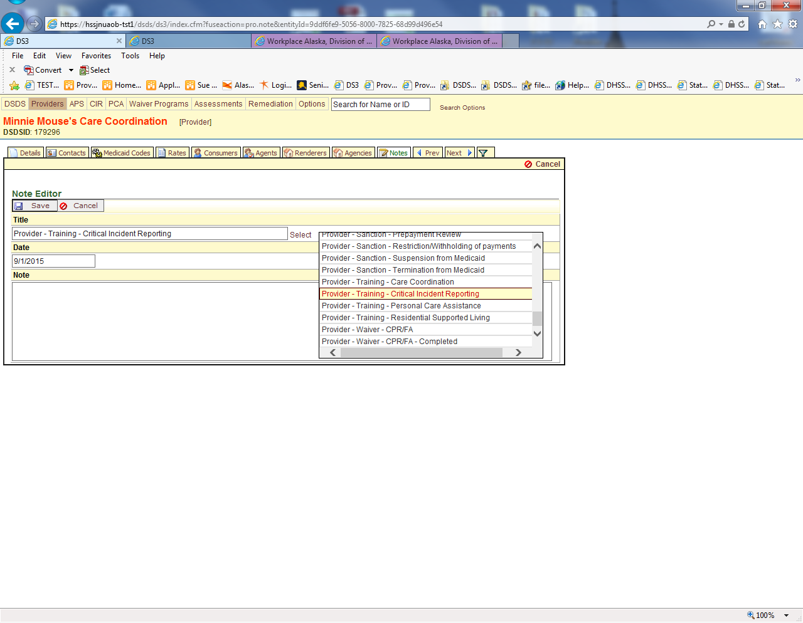

## PCA

1. For a PCA Agency Click on the Select button to the right of the Title field. Choose the “Provider – Training – Personal Care Assistance” title
   1. change the date to the date the training was completed
   2. enter a note that states who attended the training and the dates. This should be the Program Admin or an owner

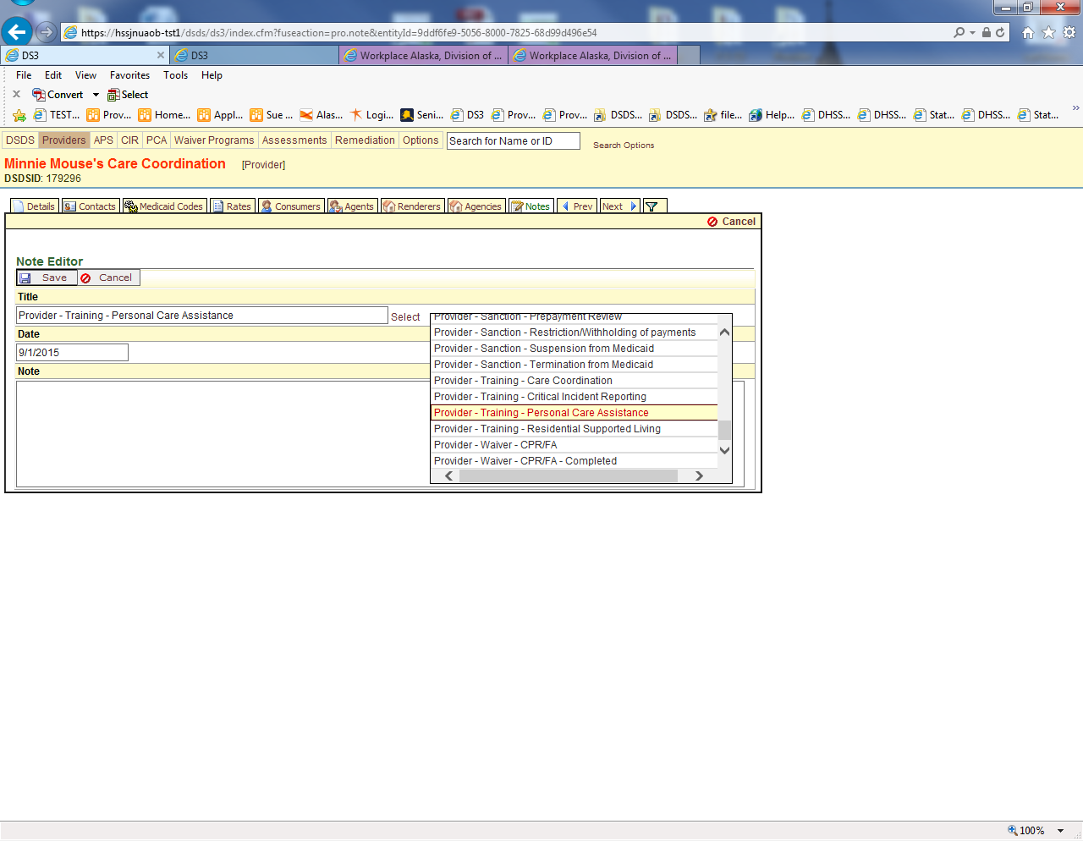

## RSL

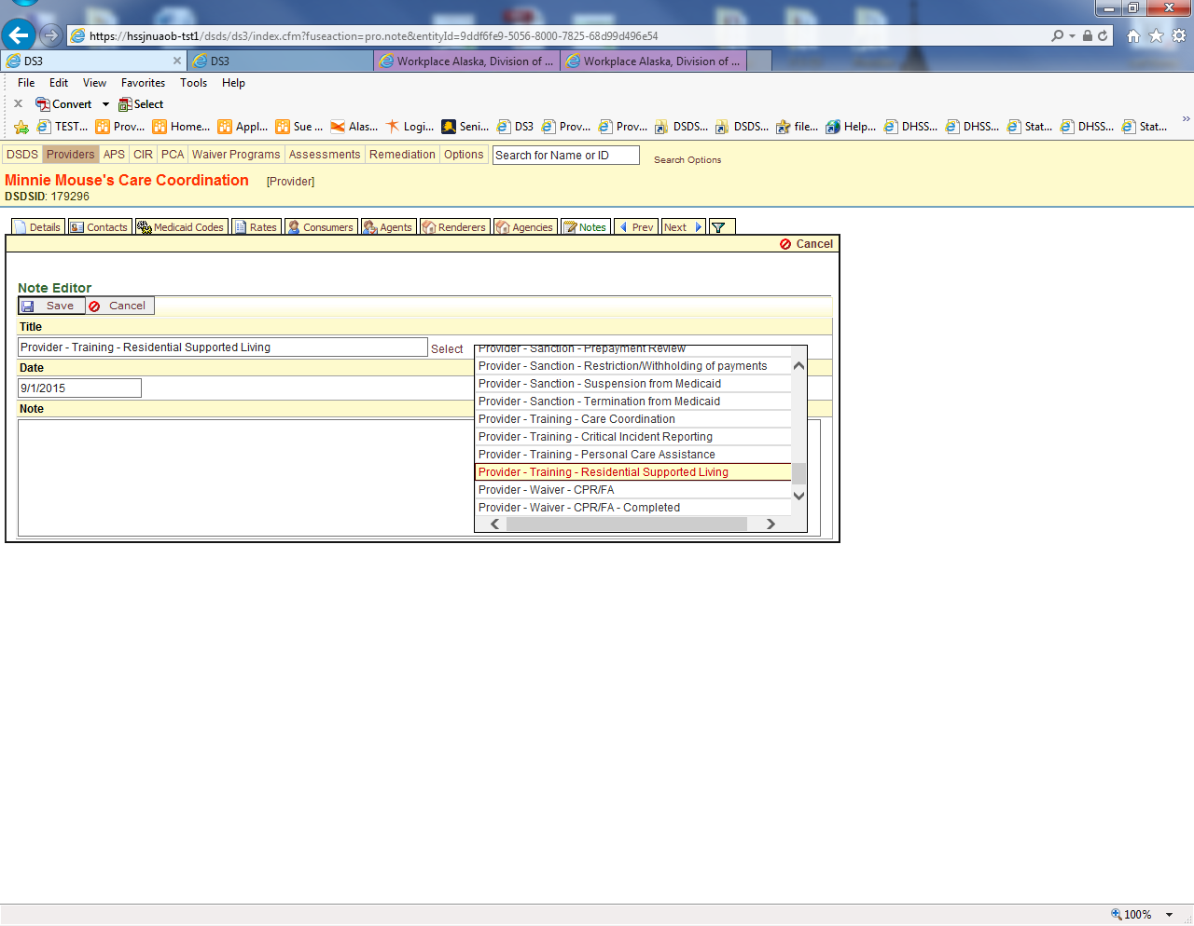

1. Click on “Add Note”. Click on the Select button to the right of the Title field. Choose the “Provider – Certification - Application Complete” title and enter a note that states the application was approved.

# Certification Forms

HCB

PCA

Care Coordinator

# Folders

## HCB (Blue)

## Care Coordinators

## PCA (Grey)

# Activating Providers

Report from Xerox via COGNOS or from provider or from staff

## Details

Active = Yes

## Contacts

quick check to make sure they were entered

## Medicaid Codes

Double check connections

# Recertifications

## Recertification Letters move down?

* + - * Recertification applications submission reminders are sent to all providers with upcoming certification end dates no later than 90 days prior to the end date.

1st & second notices and time frames

### Report

### Mail Merge

Each step including PDF

### Envelopes

Merges including PDF

### Notes

## Reviews

## Pend Notices

## DS3 Details

### Most Providers

### RSL

### PCA

## https://cdn0.iconfinder.com/data/icons/trio-miscellaneous/32/reminder-3-512.pngContacts

### Owners

### Program Administrators

### Back Up Care Coordinators

## Medicaid

### Recertification

### https://cdn0.iconfinder.com/data/icons/trio-miscellaneous/32/reminder-3-512.pngExtensions

## Agents

Care Coordinators affiliated with the agency need to be updated

## Renderers

Habilitation homes affiliated with the agency need to be updated

## Agencies

Care Coordinators need to be affiliated with the correct agency especially dual or triple affiliations

## Notes

### Pend Notices

### Denial Letters

### https://cdn0.iconfinder.com/data/icons/trio-miscellaneous/32/reminder-3-512.pngContact Notes

## Late Recertification Applications

* If provider is late in getting their recertification documents in to SDS after notices are sent, the following process should be followed:
  + Administrative support staff notifies provider of the certification expiration date and reminds the provider to give 30 days’ notice to participants. This is the final notice that is sent 45 days prior to certification end date.
  + After appeal rights have expired and an appeal was not submitted, Certification Supervisor e-mails Chief of Programs, Manager of NFLOC unit, and Manager of IDD Unit and APS this information and they will contact the Care Coordinators to alert them.
  + Program staff will send letter to participant, cc’ing the Care Coordinator

## Recertification Application approvals

* Place latest application and file in the “To Be Foldered” box
* Place the Offsite Storage folder in the Offsite Box
* Always keep certification forms in the hard copy folder in the first section

# Other Application Types

## Withdrawls

**Withdrawn Applications**

* When an agency requests to withdraw the application prepare the Application Withdrawn notice, scan the letter and application, and return both to the agency.
* Note as withdrawn in DS3, change the Medicaid code from xxAPP to xxW, and enter a case note that the application was withdrawn.

## Changes in Business Type

**Change in business type requiring a new provider number**

* If an agency changes their business type and/or gets a new tax ID/EIN number, then they are required to get a new provider number with Xerox.
* If there has been no change in ownership, then do a cert form ending the certification for the current provider number.
* Complete a separate cert form to request a new provider number.
* Change the end date for the current provider number and change status to “Inactive – Voluntary Closure”
* Register a new number (RLX, CMGX, etc.) and enter is DS3 as if a new initial provider.
* If there is a change in ownership, then the new provider(s) will need to submit a new initial application before the new provider number can be approved.

## Agency sale

* New owner will need to apply for certification and complete all the requirements. Certification does not transfer with the sale.
* Once certification requirements are met will approve the new provider following same procedures as an Initial Cert and end the current provider following the above procedures.
* If the current provider has clients who wish to remain with the new provider then it is important that the certification is not ended before the new provider is ready to be approved. If this happens then the clients will be in an uncertified facility and the new provider will not be able to bill Medicaid.
* If this is involving a licensed facility, keep in touch with licensing to ensure that the license is not changed before the certification can be approved.

## Add location

## Add CC

## Add service

# Denials

**Denial Of Certification- Certification Staff**

* Use the Notice of Denial of Certification template, which clearly states the timeline of actions and reasons for denial
* If a recertification, extend the agency certification end date by 35 days
* Make sure all correspondence and actions with this applicant are documented in DS3
* Send the denial notice draft to Unit Manager or Certification Supervisor for review
* Add the denial to the tracking excel sheet found at G:\Quality Assurance\Provider Agency Folders\1-A  Denials & Sanctions Spreadsheet
* Keep a hard copy of the application and Notice of Denial in your office for future reference during the 30 day appeal rights period
* Prepare to help support the denial in mediation or administrative hearing if it is challenged through appeal process
* If documents are received during the 30 day appeal period that make the application complete, and the applicant or provider has not appealed the denial through the Office of the Commissioner, write a Denial Withdrawal letter, enter appropriate notes in DS3, and edit the Denial tracking excel sheet and let Supervisor or Manager know.
* If documents are received during the 30 day appeal period that make the application complete, and the applicant or provider **has** appealed the denial through the Office of the Commissioner, consult with Supervisor for next steps.
* If Denial is appealed, the Unit Manager will handle the appeal process and you may be asked to participate in mediation or hearing.
* If the Denial of Recertification is appealed, the end date for certification must be extended by 90 days to allow for due process and actions

**Denial Notice Process for Administrative Support Staff**

Initial Application Denials

* Scan notice and application that is being denied to the provider agency folder on G drive
* Mail original Denial notice and application to provider agency, via certified mail
* Mail just the Denial notice via regular mail
* Save a copy of the Denial notice in the hallway drawer marked denials

Recertification Application Denials

* Scan the Notice of Denial and application to provider agency folder on G drive
* Mail just the Denial Notice via certified and regular mail
* Save a copy of the Denial notice in the hallway drawer marked denials

Initials

Recerts

## Letters

Template

## Notes

## Administrative Hearings

# Closures

Watch RSL & GR Homes

Watch Hab providers and rendering homes

Closing out hab renderers only

## Voluntary Closure

**Agency Closures and Changes**

When an agency informs SDS that they have decided to end their certification, the file is forwarded to the Certification Supervisor and the following steps are taken:

* Send a copy of the letter “Voluntary Closure Letter Template 7.2014.docx” by regular mail. Attach a copy of the Xerox Cancel Enrollment form. Save a copy of the letter in the agency folder and keep a signed copy of it for the hard file.
* Place a note under the provider in DS3 regarding the communications.
* Once the end date is passed, the staff creates a certification forms showing the effective date of the closure and adds the comment “Certification Ended”, changing all the “Y”s to “N”s.
* A copy of the final certification form is emailed to the agency with instructions to use it to cancel enrollment, a copy is sent to Xerox, and a copy is saved in the provider’s electronic and hard file.
* Once the staff has received all the required information from the agency (a copy of any letter sent to any current clients giving them minimum of 60 days’ notice and the location of where the records of the agency will be maintained for 7 years) make a note in DS3 that this information has been received and identifying the location of the records.
* If the provider has not submitted the requested information by agency closure, send an e-mail reminding them of the required information.
* The record in DS3 is updated to reflect the end date.
* Send a message out to appropriate SDS staff about the closure once there is an effective date (if a GR home, copy GR staff to turn off GR button).
* The SDS staff will check Enterprise after 30 days to verify if the provider ended their enrollment. If Enterprise shows that this has not been done, the SDS staff will create and process a Work Order to end the enrollment.
* A copy of the work order will be placed in the electronic and hard files.
* Once the enrollment is ended the hard file will be given to administrative support staff to be archived.
* The administrative support staff will move the old agency’s electronic folder into the folder named “1-A Closed Provider Agency Folders” on the G drive in the “Provider Agency Folders”.

**Closure Process: When a Care Coordinator Leaves an Agency**

* Provider Certification is notified by the agency, care coordinator, or program staff that a care coordinator is leaving an agency.
* The assigned staff person will immediately contact the agency to confirm the report and end date.
* The assigned staff person will process the request to close and send an e-mail to the care coordinator and program administrator with instructions to complete a Xerox Cancel Enrollment form.
* DS3 updated to end all certification information with correct end date and the active button is turned off. Case note is entered regarding the closure.
  + Change the end date on the Medicaid codes, COS tab, and agency tab. Change status to “inactive – voluntary closure” where applicable.
* Hard file is pulled and the change form, cert form, and any e-mails are placed in it.
* Send an e-mail to program staff regarding the final closure actions. Include the name/provider number of the care coordination, the agency name/provider number, and the last day worked. E-mails to go to:
  + Office-ANC-HSS-DSDS Waiver
  + Office-Anc-Hss-Dsds-DD
  + Melissa Glorioso
  + Melisssa Meade
  + Sybil Blue
  + Lori Gaetzman
  + Bonnie Olsen-Lee
  + Annette Callies
* Put the casefile in the Certification Supervisor’s office.
* Certification supervisor will monitor the Enterprise system to assure that the care coordinator has been inactivated in that system. If not, a work order will be completed to force the disenrollment.

## Involuntary Closure

# Archiving

## Offsite

Active 1yr on site then 20 off site

## Voluntary Closed

1 yr min on site then 7 off site

## Involuntary Closed

1yr min on site can be more then 10 off site

## Recalling a file

Excels from pre SP

SP

Form

# Reports

## Weekly

Cert status

## Monthly

CC list

PCA list

## Ad Hoc on demand

Common reports used

Common Excel tools used

Mashing more than one report to get what is needed

# Non HCB or PCA Certified Providers

## DME

COS

## SME

COS

## LTC

## ICF